Annual Report
2013–2014

Citation: ECART. 2018. Ethics Committee on Assisted Reproductive Technology
Annual Report 2013–2014. Wellington: Ethics Committee on Assisted Reproductive Technology.
Published in July 2018 by the Ethics Committee on Assisted Reproductive Technology
PO Box 5013, Wellington, New Zealand
ISBN: 978-1-98-853959-1 (online)
HP 6810
This document is available on the ECART website: www.ecart.health.govt.nz

Contents
About ECART 1
Purpose of this report 1
Chairperson’s report 2
Applications 2
Additional function 2
Committee members 2
Membership and attendance 3
Membership 3
Attendance 5
Applications reviewed 6
Creation and use, for reproductive purposes, of an embryo created from donated eggs in conjunction with donated sperm 7
Surrogacy arrangements involving providers of fertility services 7
Donation of eggs or sperm between certain family members 7
Embryo donation for reproductive purposes 7
Storage extension applications 7
Issues and complaints 7
Advice on established procedures 7
Issues referred to ACART 7
Complaints received 7
Appendix A: Applications reviewed by ECART in 2013/14 12
Appendix B: Applications reviewed by ECART before 1 July 2013 but ongoing throughout 2013/14 12
Appendix C: Storage extension applications received 1 July 2013–30 June 2014 12

List of Figures
Figure 1: The number and type of applications reviewed by ECART by year, 2005/06–2013/14 6
Figure 2: Birth outcomes from current applications for creating and using, for reproductive purposes, an embryo created from donated eggs in conjunction with donated sperm by year, 2010/11–2013/14 7
Figure 3: Birth outcomes from current applications for surrogacy arrangements involving providers of fertility services by year, 2005/06–2013/14 7
Figure 4: Birth outcomes from current applications for the donation of eggs or sperm between certain family members by year, 2005/06–2013/14 7
Figure 5: Birth outcomes for current applications from embryo donation, by year, 2005/06–2013/14 7
Figure 6: Types of storage extension applications, 2013/14 7

About ECART
The Ethics Committee on Assisted Reproductive Technology (ECART) is the ethics committee for the purposes of the Human Assisted Reproductive Technology Act 2004 (the HART Act), which aims to secure the benefits of these technologies by promoting and protecting the health, safety, dignity and rights of those involved in them.

Under the HART Act, ECART’s prior approval is required in order to conduct:
- human reproductive research (that is, research that involves the creation or use of human gametes, human embryos or hybrid embryos)
- assisted reproductive procedures, except those that have been declared to be ‘established procedures’.

ECART’s main role is to review applications from fertility clinics that wish to conduct ‘assisted reproductive procedures’ on individuals, or ‘human reproductive research’, against guidelines issued by the Advisory Committee on Assisted Reproductive Technology (ACART).

Purpose of this report
ECART’s Terms of Reference require it to report annually to the Minister of Health.

This report must include information on the membership of the committee, a summary of the applications reviewed during the year, details of any complaints received (and how they were resolved) and areas of review that caused difficulty in making decisions. The report should also detail the number and type of applications for assisted reproductive procedures and human reproductive research, the date of first review, the final outcome and the reason for deferring or declining any applications.

Chairperson’s report
I am pleased to present the ninth Annual Report of ECART, for the year ending 30 June 2014.

Applications
In 2013/14, ECART reviewed 29 applications over five meetings; compared with the 2012/13 year when it reviewed 55 applications over five meetings. ECART also reviewed, for the first time since the HART Act 2004 came into effect, applications to extend the storage period of gametes and embryos beyond their original 10-year limit. ECART reviewed 49 applications for extended storage over five meetings. ECART expects the number of extended storage applications to significantly increase in the next year as the original 10-year storage period provided for in the HART Act ends in November 2014.

Additional function
Following a request from fertility clinics to be able to approach ECART for informal advice on established procedures, ECART wrote to the Minister of Health (the Minister) asking for this function to be assigned pursuant to section 28(1)(e) of the HART Act. The Minister agreed to assign this function to ECART and asked for details of such advice to be included in future Annual Reports. These details can be found on page 13 of this report.

Committee members
I wish to officially welcome Ms Jo Fitzpatrick to ECART. Jo has had extensive involvement in representing women’s health issues from a consumer perspective and has been appointed to ECART in this capacity. Jo also brings a bicultural perspective to ECART’s decision-making process.

I wish to record my gratitude and thanks to all the committee members for their continuing commitment, without which the committee could not function effectively. I look forward to another interesting and fulfilling year in 2014/15.

Kate Davenport QC
Chairperson

Membership and attendance

Membership

Lay members
Ms Kate Davenport QC (Chairperson)
Membership category: expertise in the law
Date of first appointment: 7 August 2008
Current term expires: 21 July 2014*
Ms Kate Davenport QC is a barrister sole practising in the area of civil and commercial litigation in Auckland. Kate has an LLB Honours, Master of Jurisprudence with Distinction and a post-graduate certificate in Health Science (Ethics). Kate has a particular interest in health law. Kate was the Deputy Chair of the New Zealand Health Practitioners Disciplinary Tribunal, a tribunal that disciplines all registered health practitioners in New Zealand. Kate has also been the Director of Proceedings for the Health and Disability Commissioner.
Dr Brian Fergus
Membership category: consumer perspective
Date of first appointment: 1 April 2012
Current term expires: 1 April 2015
BSc, MSc (1st class Honours) Auckland, PhD, McGill University, Montreal, Canada
Dr Brian Fergus has previous private-sector experience at management level and senior management consulting experience. He was also elected Board member of Auckland District Health Board, where he chaired the Community Health subcommittee and was a member of the Audit Committee. Currently, he is Chair of Northern A Health and Disability Ethics Committee. Dr Fergus has four children and seven grandchildren.
Dr Adriana Gunder QSM JP
Membership category: disability perspective
Date of first appointment: 1 April 2010
Current term expires: 1 April 2016
Dr Adriana Gunder is a disability representative and a member of both the New Zealand Health Practitioners Disciplinary Tribunal and the National Ethics Advisory Committee (NEAC). Dr Gunder completed her doctoral degree in Biological Sciences and a post-doctoral degree in Biophysics at the University of Pavia, Italy. She is the Chairperson of the Local Council of Auckland Central, East and South of the New Zealand Red Cross. She has been an elected member of the Auckland City Council: Eastern Bays Community Board (2006–2010) and a volunteer of Victim Support (1995–2007).
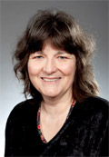 | Dr Carolyn Mason  Membership category: expertise in ethics  Date of first appointment: 21 July 2011  Current term expires: 21 July 2014  Dr Carolyn Mason is currently a lecturer in Ethics at the University of Canterbury  (2001–present). Before this, she was a lecturer at Lincoln University (2000) and a science research technician (1979–1985). Dr Mason completed a Bachelor of Science in Psychology and Philosophy (1992), a Master of Arts in Philosophy (1999) and a Doctor of Philosophy in Philosophy at the University of Canterbury (2013). She was a member and Chair of the Upper South A Regional Ethics Committee (2005–2008), and a member and Deputy Chair of the Canterbury Regional Health and Disability Ethics Committee (2002–2004). She is currently a member of the University of Canterbury Human Ethics Committee.
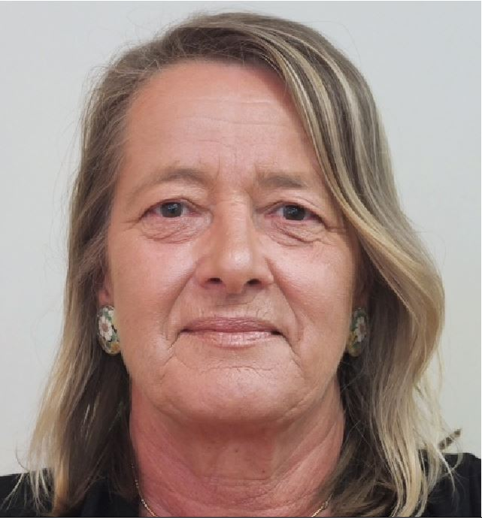 | Ms Jo Fitzpatrick  Membership category: consumer perspective  Date of first appointment: 30 May 2013  Current term expires: 1 April 2015  Ms Jo Fitzpatrick’s involvement in women’s health provides the foundation for her interest in fertility issues from a consumer perspective. Ms Fitzpatrick has been the Director at Women’s Health Action Trust, a generalist organisation that has represented the broader constituencies in the fertility debate.  The principles that informed the Women’s Health Action Trust submissions in the fertility debate during Ms Fitzpatrick’s time there also form the basis of ECART’s guiding principles. Ms Fitzpatrick’s role at Women’s Health Action Trust has also afforded her extensive opportunities to represent consumers and articulate issues from a consumer perspective.

Non-lay members
Dr Freddie Graham
Membership category: expertise in human reproductive research
Date of first appointment: 21 July 2011
Current term expires: 21 July 2014
Dr Freddie Graham is currently an obstetrician and gynaecologist at Fertility Associates. He established Fertility Associates as New Zealand’s first private fertility clinic in 1987 and was awarded the Companion of the New Zealand Order of Merit for his services to medicine in 2009. Dr Graham has completed a Bachelor of Medicine and Bachelor of Surgery at the University of London and has been made a Fellow of The Royal College of Surgeons of Edinburgh, as well as a Fellow of The Royal Australian and New Zealand College of Obstetricians and Gynaecologists.
Dr Deborah Payne
Membership category: expertise in assisted reproductive procedures
Date of first appointment: 1 April 2012
Current term expires: 1 April 2014*
Dr Deborah Payne is a senior lecturer and co-director of the Centre for Midwifery and Women’s Health Research at Auckland University of Technology (AUT). She completed her PhD at Massey University in 2003. Dr Payne has a longstanding interest in women’s health. Recent research projects have explored issues in relation to women and disability (eg, motherhood and disability) and assisted reproductive technologies (eg, perceptions of short-cycle IVF, nurses caring for clients undergoing ART and embryo donation). Dr Payne is a member of the Auckland Women’s Health Council.
Dr Deborah Rowe
Membership category: expertise in assisted reproductive procedures
Date of first appointment: 28 June 2007
Current term expires: 21 July 2014
Dr Deborah Rowe (Ngāi Tahu) is currently a nurse consultant for the Auckland District Health Board (Auckland DHB), a lecturer at The University of Auckland and a senior staff nurse at the Women’s Health Neonatal Intensive Care Unit (NICU). She is a member of the Nursing Council of New Zealand, the Māori Advisory Committee National Screening Unit, the Newborn Screening Advisory Committee, the Auckland DHB Māori Nurses Group, as well as a part-time community support worker for the Intellectually Handicapped of New Zealand (IHC).
* Unless a person vacates their office sooner, every appointed member of ECART shall continue in office until their successor comes into office (ECART Terms of Reference).

Attendance
ECART held five meetings in the year 1 July 2013 to 30 June 2014.

 |  | Meeting dates
 |  | 1/8/13 | 5/9/13 | 7/11/13 | 6/3/14 | 5/5/14 | Total
Members | Ms Kate Davenport (Chair, L) |  |  |  |  |  | 5/5
 | Dr Brian Fergus (C) |  |  |  |  |  | 5/5
 | Dr Adriana Gunder (D) |  |  |  |  |  | 5/5
 | Dr Carolyn Mason (E) |  |  |  |  |  | 5/5
 | Ms Jo Fitzpatrick (C) |  |  |  |  |  | 5/5
 | Dr Freddie Graham (HRR) |  |  |  |  |  | 5/5
 | Dr Deborah Payne (ARP) |  |  |  |  |  | 5/5
 | Dr Deborah Rowe (ARP) |  | A | A |  |  | 3/5
 | Total members attending | 8/8 | 7/8 | 7/8 | 8/8 | 8/8 | –
Applications | Surrogacy | 0 | 1 | 2 | 5 | 3 | 11
 | Embryo donation for reproductive purposes | 1 | 2 | 3 | 3 | 2 | 11
 | Donation of eggs or sperm between certain family members | 1 | 0 | 1 | 1 | 0 | 3
 | Creation and use, for reproductive purposes, of an embryo created from donated eggs in conjunction with donated sperm | 0 | 0 | 1 | 0 | 1 | 2
 | Human reproductive research | 0 | 1 | 0 | 0 | 0 | 1
 | Pre-implantation genetic diagnosis | 1 | 0 | 0 | 0 | 0 | 1
 | Total applications reviewed | 3 | 4 | 7 | 9 | 6 | 29
* The number of applications reviewed may differ from the number of applications received as some applications may have been deferred and reviewed at a second meeting.
A = Apologies, = Present, = Māori member
Membership categories:
L = expertise in the law
E = expertise in ethics
D = disability perspectives
C = member with the ability to articulate issues from a consumer or community perspective
ARP = member with expertise in assisted reproductive procedures
HRR = member with expertise in human reproductive research

Applications reviewed
ECART reviewed 29 applications in 2013/14. These included two applications for donated eggs in conjunction with donated sperm (the third year in which ECART has reviewed this type of application), one application for human reproductive research, three applications for donation of eggs or sperm between certain family members, 11 applications for embryo donation, 11 applications for surrogacy arrangements involving providers of fertility services and one application for pre-implantation genetic diagnosis (PGD) with human leucocyte antigen (HLA) tissue typing.

This is the first year that ECART has reviewed an application for PGD with HLA tissue typing. The guidelines were issued to ECART in 2005, and they allow ECART to consider applications for a tissue match for an unwell child with a serious familial single gene disorder or a familial sex-linked disorder where there are no other possibilities for treatment or tissue available and the cord blood of an existing sibling is used.

Figure 1: The number and type of applications reviewed by ECART by year, 2005/06–2013/14
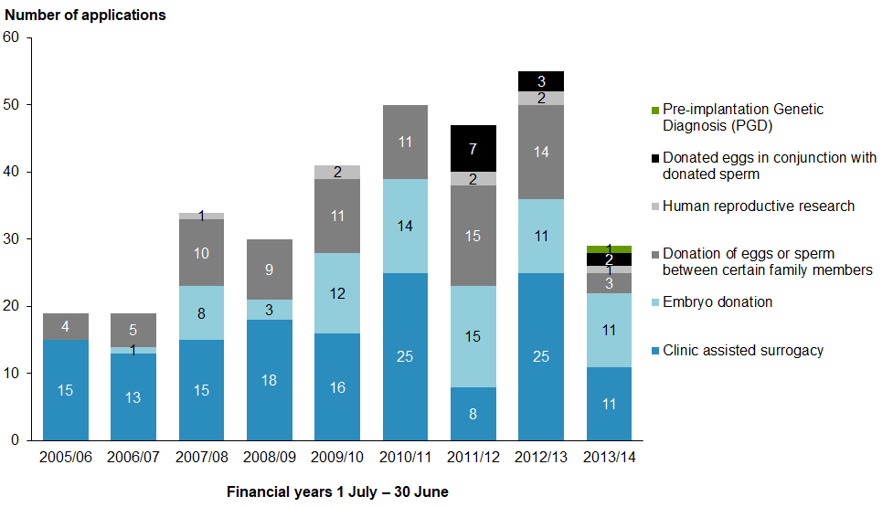

Of the 27 assisted reproductive procedure applications reviewed in 2013/14, a total of 16 were approved at first review, four were approved subject to conditions, and six were deferred.

ECART gave non-binding ethical advice on one surrogacy arrangement that involved an established procedure as the birth mother’s own eggs were used. ECART advised the fertility provider that it was supportive of the fertility provider’s decision to seek its views and non-binding ethical advice on the proposed surrogacy given that surrogacy is ethically and legally complex and involves risks for the adult parties and resulting children. ECART advised the provider that the proposed surrogacy was justified in light of the associated risks.

One assisted reproductive procedure approved in 2013/14 resulted in a live birth before 30 June 2014.

ECART approved one application in 2013/14 for human reproductive research on non-viable gametes and embryos and one application for PGD with HLA tissue typing.

Creation and use, for reproductive purposes, of an embryo created from donated eggs in conjunction with donated sperm
In 2013/14, ECART reviewed two applications for the creation and use, for reproductive purposes, of an embryo created from donated eggs in conjunction with donated sperm. This is the third year in which ECART has reviewed this type of application.

As of 1 July 2014, one application was approved, and one was approved subject to conditions.

Applications for this category are current for three years from the date of approval. Of the 12 applications that have current ECART approval in this category, there was one live birth during 2013/14.

Figure 2: Birth outcomes from current applications for creating and using, for reproductive purposes, an embryo created from donated eggs in conjunction with donated sperm by year, 2010/11–2013/14
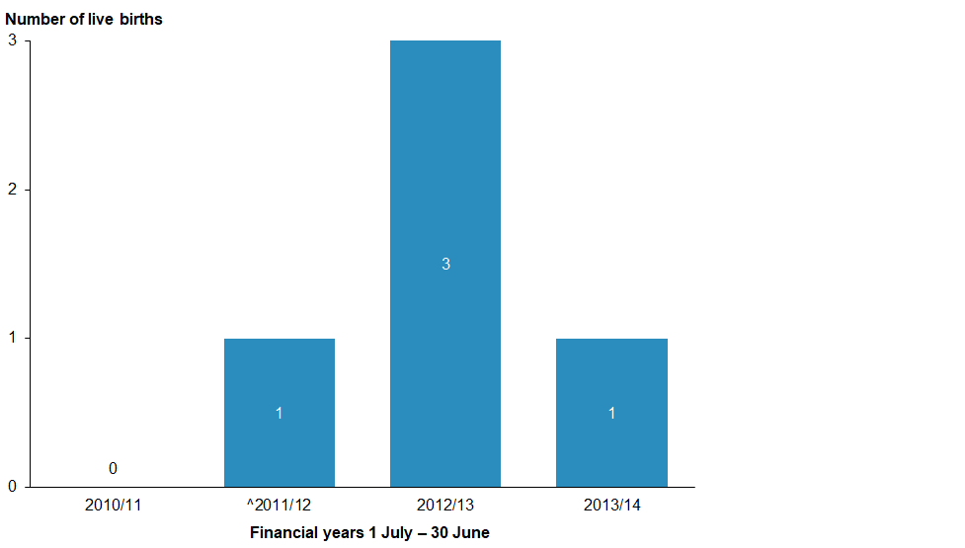
* Applications are current for three years; births resulting in the fourth year have not been captured in this figure.
^ 2011/12 was the first year in which applications of this type were reviewed.

Surrogacy arrangements involving providers of fertility services
In 2013/14, ECART reviewed 11 applications for surrogacy arrangements involving providers of fertility services.

As of 1 July 2014, five of the 11 surrogacy applications received by ECART in 2013/14 were approved, two applications were approved subject to conditions, and four applications were deferred.

The number of clinic assisted surrogacy applications received in 2013/14 decreased by 52 percent from the last reporting year.

Applications for this category are current for three years from the date of approval. Of the 67 applications for surrogacy that have current ECART approval, there were nine live births in 2013/14.

Surrogacy applications approved by ECART have so far resulted in 46 live births.

Figure 3: Birth outcomes from current applications for surrogacy arrangements involving providers of fertility services by year, 2005/06–2013/14
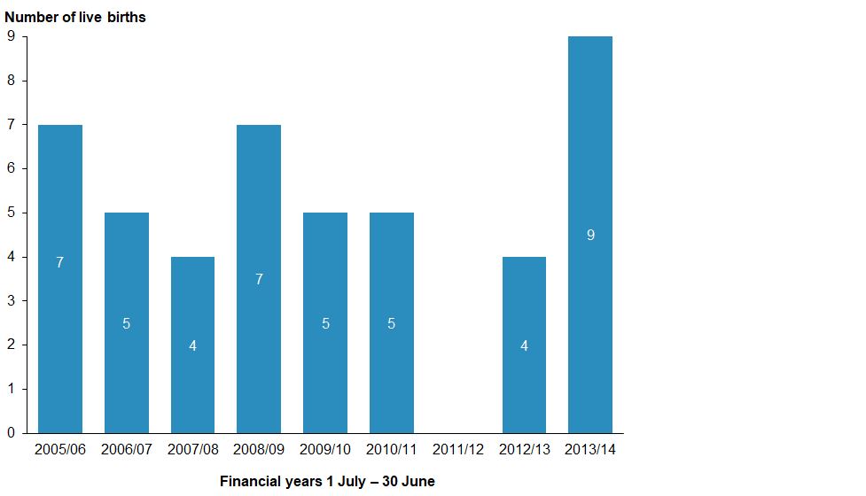
* Applications are current for three years; births resulting in the fourth year have not been captured in this figure.

Donation of eggs or sperm between certain family members
In 2013/14, ECART reviewed three applications for the donation of eggs or sperm between family members, which is a decrease of 78.5 percent from the previous year.

As of 1 July 2014, all three applications had been approved.

Applications for this category are current for three years from the date of approval. Of the 41 applications in this category that have current ECART approval, there were 10 live births during 2013/14.

Figure 4: Birth outcomes from current applications for the donation of eggs or sperm between certain family members by year, 2005/06–2013/14
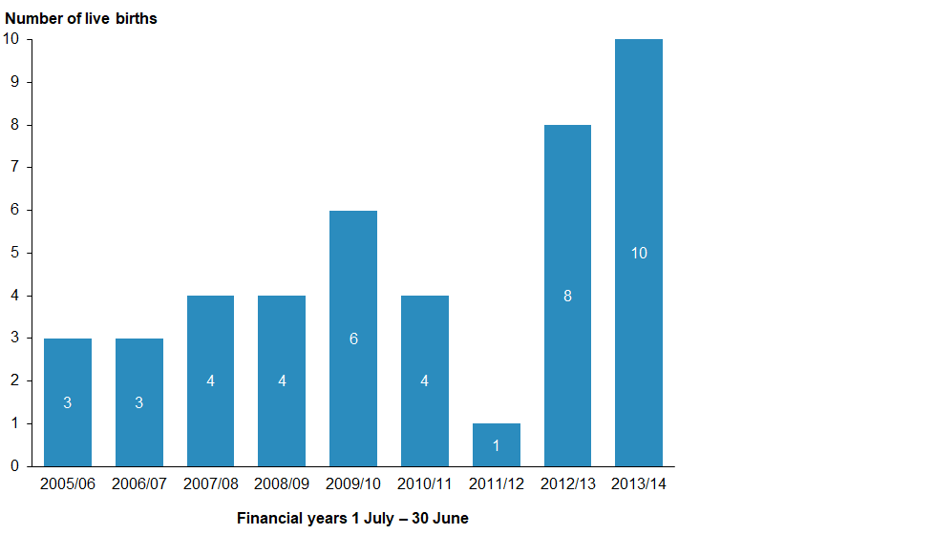
* Applications are current for three years; births resulting in the fourth year have not been captured in this figure.

Embryo donation for reproductive purposes
ECART reviewed 11 applications involving embryo donation for reproductive purposes in 2013/14, the same number as in 2012/13.

As of 1 July 2014, eight applications were approved, one was approved subject to conditions, one was deferred and one was declined.

Applications for this category are current for three years from the date of approval. Of the 47 applications for this category that have current ECART approval, there were three live births during 2013/14.

The use of this assisted reproductive procedure following ECART approval has resulted in a total of 27 live births so far.

Figure 5: Birth outcomes for current applications from embryo donation, by year,
2005/06–2013/14
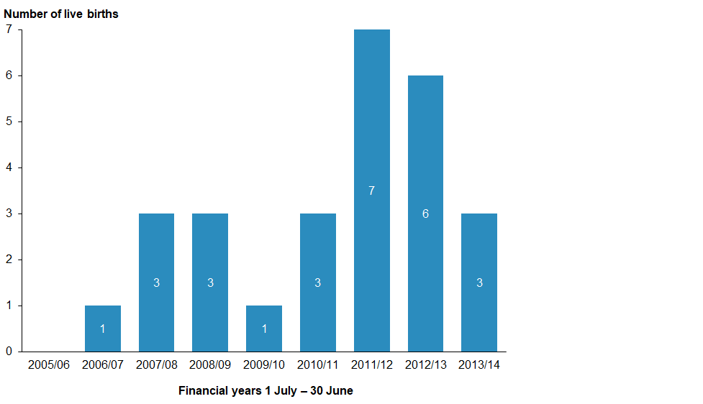
* Applications are current for three years; births resulting in the fourth year have not been captured in this figure.

Storage extension applications
Under the HART Act 2004, gametes and embryos can be stored for an initial period of up to 10 years. For continued lawful storage after the storage expiry date, ECART must approve an extension.

In September 2012, ACART issued guidelines to ECART so that ECART could consider applications from individuals who wished to extend the storage period of their gametes or embryos.

The original 10-year period began in November 2004, when the HART Act commenced, and 2014 was the first year that ECART reviewed such applications.

ECART had reviewed 49 applications for extended storage as at 30 June 2014. Of the reviewed applications, 33 were for extended storage of stored sperm, 14 were for extended storage of embryos, and two were for extended storage of both embryos and sperm.

As of 1 July 2014, there were 47 approved applications and two declined applications.

Figure 6: Types of storage extension applications, 2013/14
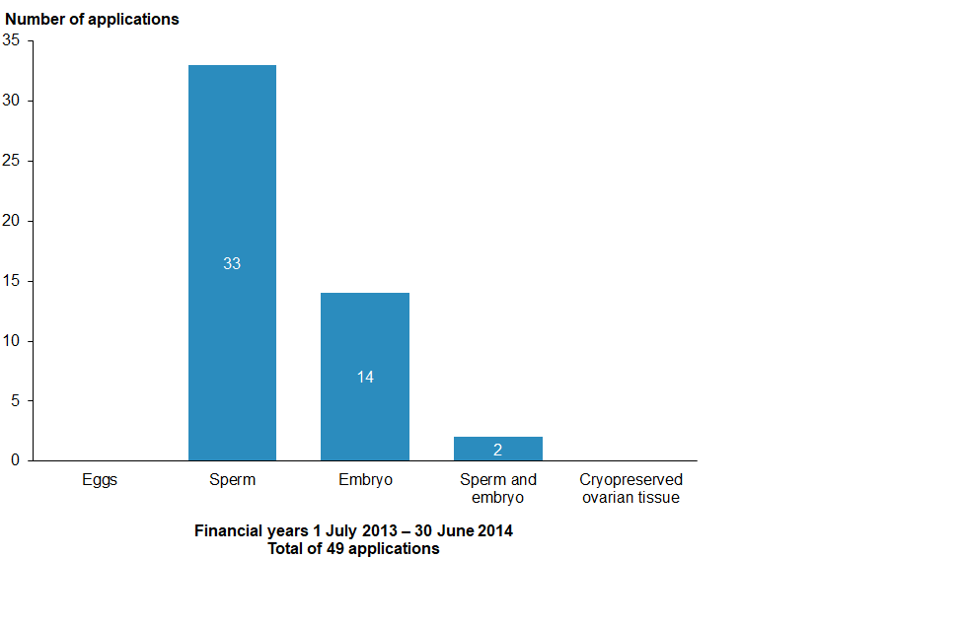

Issues and complaints
This section outlines issues faced by the committee during 2013/14.

Advice on established procedures
In February 2011, the Minister of Health assigned ECART the function of giving ethical advice to fertility clinics on established procedures when requested by a fertility clinic to do so. One such request was received in 2013/14. The request involved the ethics of performing an established procedure in a traditional surrogacy arrangement where the surrogate mother would also be the egg donor.

Issues referred to ACART
In 2013/14, ECART referred a research proposal for human reproductive research to ACART as a result of not being able to review the proposal itself in the absence of guidelines.

In October 2013, ECART received a request for ethical consideration of an application to conduct human reproductive research where the researcher intended to randomly select day-3 and day-5 embryos created as part of in-vitro fertilisation (IVF) treatment to analyse the outcomes and see which yielded a higher cumulative birth rate.

The randomisation of embryos in the study was deemed to be ‘use’ of the embryos. ACART has not issued guidelines on human reproductive research involving viable embryos, and in the absence of ACART guidelines, ECART could not consider or approve an application that involved the use of viable embryos.

Section 19(2) of the HART Act prohibits ECART from giving an approval unless it is satisfied that the activity proposed to be undertaken under the approval is consistent with relevant guidelines or relevant advice issued or given by the advisory committee (ACART).

ECART therefore had to decline the application and refer it to ACART in accordance with section 18(2)(a) and (b) of the HART Act 2014.

ACART advised that the referral had strengthened the case for reviewing the human reproductive research guidelines.

Complaints received
ECART did not receive any complaints during 2013/14.

Appendix A: Applications reviewed by ECART in 2013/14
App# | Date of first review | Initial decision | Final decision | Type of procedure | Approval end date
E13/09 | 7 March 2013 | Deferred |  | Clinic-assisted surrogacy | 14 November 2016
E13/24 | 1 August 2013 | Approved |  | Donation of eggs or sperm between certain family members | 2 August 2016
E13/25 | 1 August 2013 | Approved |  | Embryo donation | 2 August 2016
E13/26 | 1 August 2013 | Approved STC |  | Pre-implantation genetics diagnosis | 2 August 2016
E13/27 | 5 September 2013 | Approved |  | Embryo donation | 18 September 2016
E13/28 | 5 September 2013 | Approved |  | Embryo donation | 7 October 2016
E13/29 | 5 September 2013 | Deferred | Approved | Clinic-assisted surrogacy | 1 November 2016
E13/30 | 5 September 2013 | Approved STC |  | Research
E13/31 | 7 November 2013 | Deferred | Declined | Embryo donation
E13/32 | 7 November 2013 | Approved STC |  | Clinic-assisted surrogacy | 27 February 2017
E13/33 | 7 November 2013 | Approved |  | Embryo created from donated eggs in conjunction with donated sperm | 14 November 2016
E13/34 | 7 November 2013 | Approved |  | Embryo donation | 14 November 2016
E13/35 | 7 November 2013 | Approved |  | Embryo donation | 14 November 2016
E13/36 | 7 November 2013 |  |  | Clinic-assisted surrogacy
E10/47 | 7 November 2013 | Approved |  | Donation of eggs or sperm between certain family members | 14 November 2016
E14/01 | 6 March 2014 | Approved |  | Clinic-assisted surrogacy | 14 March 2017
E14/02 | 6 March 2014 | Deferred |  | Embryo donation
E14/03 | 6 March 2014 | Approved STC |  | Embryo donation
E14/04 | 6 March 2014 | Approved |  | Clinic-assisted surrogacy | 14 March 2017
E14/05 | 6 March 2014 | Approved |  | Clinic-assisted surrogacy | 14 March 2017
E14/06 | 6 March 2014 | Deferred | Approved | Clinic-assisted surrogacy | 5 May 2017
E14/07 | 6 March 2014 | Approved |  | Donation of eggs or sperm between certain family members | 14 March 2017
E14/08 | 6 March 2014 | Approved |  | Clinic-assisted surrogacy | 14 March 2017
E14/56 | 5 May 2014 | Approved |  | Embryo donation | 13 May 2017
E14/57 | 5 May 2014 | Approved |  | Embryo donation | 13 May 2017
E14/58 | 5 May 2014 | Approved |  | Clinic-assisted surrogacy | 13 May 2017
E14/59 | 5 May 2014 | Approved STC | Approved | Clinic-assisted surrogacy | 17 June 2017
E14/62 | 5 May 2014 | Approved STC | Approved | Embryo created from donated eggs in conjunction with donated sperm | 26 May 2017
E10/42 | 5 May 2014 | Deferred | Approved | Clinic-assisted surrogacy | 27 May 2017

Appendix B: Applications reviewed by ECART before 1 July 2013 but ongoing throughout 2013/14
App# | Date of first review | Initial decision | Final decision | Procedure | Approval end date
E10/19 | 3 June 2010 | Approved |  | Embryo donation | 5 July 2013
E10/22 | 29 July 2010 | Approved |  | Clinic-assisted surrogacy | 12 August 2013
E10/23 | 29 July 2010 | Approved STC | Approved | Clinic-assisted surrogacy | 28 October 2013
E10/24 | 29 July 2010 | Approved |  | Clinic-assisted surrogacy | 12 August 2013
E10/25 | 29 July 2010 | Deferred | Approved | Donation of eggs or sperm between certain family members | 8 February 2014
E10/26 | 29 July 2010 | Approved STC | Approved STC | Embryo donation | 12 August 2013
E10/27 | 29 July 2010 | Approved |  | Clinic-assisted surrogacy | 12 August 2013
E10/28 | 29 July 2010 | Approved |  | Donation of eggs or sperm between certain family members | 12 August 2013
E10/29 | 29 July 2010 | Deferred | Approved | Clinic-assisted surrogacy | 9 December 2013
E10/30 | 29 July 2010 | Approved |  | Clinic-assisted surrogacy | 12 August 2013
E10/31 | 29 July 2010 | Approved STC | Approved | Donation of eggs or sperm between certain family members | 22 September 2013
E10/32 | 29 July 2010 | Deferred | Deferred | Clinic-assisted surrogacy | N/A
E10/33 | 29 July 2010 | Approved |  | Clinic-assisted surrogacy | 12 August 2013
E10/34 | 16 September 2010 | Approved STC | App with recs | Clinic-assisted surrogacy | 22 September 2013
E10/35 | 16 September 2010 | Approved |  | Clinic-assisted surrogacy | 22 September 2013
E10/36 | 16 September 2010 | Approved | Declined to review | Research | N/A
E10/37 | 16 September 2010 | Declined | Declined | Donation of eggs or sperm between certain family members | N/A
E10/38 | 16 September 2010 | Approved |  | Embryo donation | 22 September 2013
E10/39 | 16 September 2010 | Approved |  | Clinic-assisted surrogacy | 22 September 2013
E10/40 | 16 September 2010 | Approved |  | Embryo donation | 22 September 2013
E10/41 | 25 November 2010 | Approved |  | Donation of eggs or sperm between certain family members | 9 December 2013
E10/42 | 25 November 2010 | Deferred | Approved STC | Clinic-assisted surrogacy | 15 December 2013
E10/43 | 25 November 2010 | Approved |  | Clinic-assisted surrogacy | 9 December 2013
E10/44 | 25 November 2010 | Approved |  | Clinic-assisted surrogacy | 9 December 2013
E10/45 | 25 November 2010 | Approved |  | Clinic-assisted surrogacy | 9 December 2013
E10/46 | 25 November 2010 | Approved |  | Clinic-assisted surrogacy | 9 December 2013
E10/47 | 25 November 2010 | Approved |  | Donation of eggs or sperm between certain family members | 9 December 2013
E10/48 | 25 November 2010 | Approved |  | Clinic-assisted surrogacy | 9 December 2013
E10/49 | 25 November 2010 | Approved |  | Clinic-assisted surrogacy | 9 December 2013
E11/01 | 17 February 2011 | Approved |  | Donation of eggs or sperm between certain family members | 3 March 2014
E11/02 | 17 February 2011 | Approved |  | Clinic-assisted surrogacy | 3 March 2014
E11/03 | 17 February 2011 | Deferred | Approved | Embryo donation | 1 December 2014
E11/04 | 17 February 2011 | Approved |  | Donation of eggs or sperm between certain family members | 3 March 2014
E11/05 | 17 February 2011 | Approved |  | Donation of eggs or sperm between certain family members | 3 March 2014
E11/07 | 17 February 2011 | Approved |  | Clinic-assisted surrogacy | 3 March 2014
E11/08 | 17 February 2011 | Approved STC | Approved | Embryo donation | 24 March 2014
E11/09 | 17 February 2011 | Deferred | Approved | Embryo donation | 16 March 2014
E11/10 | 17 February 2011 | Approved |  | Clinic-assisted surrogacy | 3 March 2014
E11/11 | 17 February 2011 | Approved |  | Clinic-assisted surrogacy | 3 March 2014
E11/12 | 17 February 2011 | Approved |  | Clinic-assisted surrogacy | 3 March 2014
E11/13 | 12 May 2011 | Approved |  | Embryo donation | 26 May 2014
E11/14 | 12 May 2011 | Approved STC | Approved | Embryo donation | 23 June 2014
E11/15 | 12 May 2011 | Approved STC | Approved | Clinic-assisted surrogacy | 26 May 2014
E11/16 | 12 May 2011 | Approved |  | Embryo donation | 26 May 2014
E11/17 | 12 May 2011 | Approved |  | Donation of eggs or sperm between certain family members | 26 May 2014
E11/18 | 12 May 2011 | Approved |  | Donation of eggs or sperm between certain family members | 26 May 2014
E11/19 | 12 May 2011 | Approved |  | Embryo donation | 26 May 2014
E11/20 | 12 May 2011 | Deferred | Approved | Embryo donation | 17 June 2014
E11/22 | 12 May 2011 | Approved |  | Embryo donation | 26 May 2014
E11/23 | 21 July 2011 | Approved |  | Donation of eggs or sperm between certain family members | 4 August 2014
E11/24 | 21 July 2011 | App with recs |  | Embryo donation | 4 August 2014
E11/25 | 21 July 2011 | Approved STC | Approved | Embryo created from donated eggs in conjunction with donated sperm | 11 October 2014
E11/26 | 21 July 2011 | Deferred | Approved | Embryo donation | 11 October 2014
E11/27 | 21 July 2011 | Approved STC | Approved | Donation of eggs or sperm between certain family members | 14 October 2014
E11/28 | 21 July 2011 | Approved |  | Donation of eggs or sperm between certain family members | 4 August 2014
E11/29 | 21 July 2011 | Approved |  | Clinic-assisted surrogacy | 4 August 2014
E11/30 | 21 July 2011 | Approved |  | Embryo donation | 4 August 2014
E11/31 | 21 July 2011 | Approved |  | Embryo donation | 4 August 2014
E11/32 | 29 September 2011 | Approved |  | Embryo donation | 11 October 2014
E11/33 | 29 September 2011 | Approved STC | Approved | Embryo donation | 14 October 2014
E11/34 | 29 September 2011 | Approved |  | Embryo donation | 14 October 2014
E11/35 | 29 September 2011 | App with recs |  | Clinic-assisted surrogacy | 14 October 2014
E11/36 | 29 September 2011 | Approved |  | Embryo created from donated eggs in conjunction with donated sperm | 14 October 2014
E11/37 | 29 September 2011 | Approved |  | Embryo donation | 14 October 2014
E11/38 | 29 September 2011 | Approved |  | Embryo donation | 14 October 2014
E11/39 | 29 September 2011 | Approved |  | Embryo created from donated eggs in conjunction with donated sperm | 29 September 2014
E11/40 | 29 September 2011 | Approved |  | Embryo donation | 29 September 2014
E11/41 | 29 September 2011 | Deferred | Approved | Donation of eggs or sperm between certain family members | 14 October 2014
E11/42 | 24 November 2011 | Approved STC | Approved | Research | 20 January 2015
E11/43 | 24 November 2011 | Approved |  | Donation of eggs or sperm between certain family members | 1 December 2014
E11/44 | 24 November 2011 | Approved |  | Embryo created from donated eggs in conjunction with donated sperm | 1 December 2014
E11/45 | 24 November 2011 | Approved |  | Donation of eggs or sperm between certain family members | 1 December 2014
E11/46 | 24 November 2011 | Approved |  | Embryo created from donated eggs in conjunction with donated sperm | 1 December 2014
E11/47 | 24 November 2011 | Approved |  | Donation of eggs or sperm between certain family members | 1 December 2014
E11/48 | 24 November 2011 | Approved |  | Clinic-assisted surrogacy | 1 December 2014
E11/49 | 24 November 2011 | Approved |  | Embryo donation | 1 December 2014
E10/42 | 25 November 2010 | Approved |  | Clinic-assisted surrogacy | 5 March 2015
E12/01 | 23 February 2012 | Approved |  | Donation of eggs or sperm between certain family members | 5 March 2015
E12/02 | 23 February 2012 | Approved |  | Embryo donation | 5 March 2015
E12/03 | 23 February 2012 | Approved STC | Approved | Donation of eggs or sperm between certain family members | 21 March 2015
E12/04 | 23 February 2012 | Approved |  | Donation of eggs or sperm between certain family members | 5 March 2015
E12/05 | 23 February 2012 | Approved STC | Approved | Embryo created from donated eggs in conjunction with donated sperm | 16 April 2015
E12/06 | 23 February 2012 | Approved |  | Embryo created from donated eggs in conjunction with donated sperm | 5/03/2015
E12/07 | 23 February 2012 | Approved |  | Embryo donation | 5 March 2015
E12/08 | 23 February 2012 | Approved |  | Donation of eggs or sperm between certain family members | 5 March 2015
E12/09 | 10 May 2012 | Approved STC | Approved | Donation of eggs or sperm between certain family members | 14 October 2014
E12/10 | 10 May 2012 | Approved |  | Embryo donation | 15 May 2015
E12/11 | 10 May 2012 | Approved |  | Donation of eggs or sperm between certain family members | 15 May 2015
E12/12 | 10 May 2012 | Approved STC | Approved | Embryo donation | 11 June 2015
E12/13 | 10 May 2012 | Approved STC | Declined | Donation of eggs or sperm between certain family members
E12/14 | 10 May 2012 | Approved |  | Donation of eggs or sperm between certain family members | 15 May 2015
E12/15 | 10 May 2012 | Approved |  | Clinic-assisted surrogacy | 15 May 2015
E12/16 | 10 May 2012 | Approved |  | Clinic-assisted surrogacy | 15 May 2015
E12/17 | 10 May 2012 | Approved STC | Approved | Research | 17 June 2015
E12/18 | 10 May 2012 | Approved |  | Clinic-assisted surrogacy | 15 May 2015
E12/19 | 19 July 2012 | Approved STC | Approved | Embryo created from donated eggs in conjunction with donated sperm | 28 August 2015
E12/20 | 19 July 2012 | Deferred | Application withdrawn | Clinic-assisted surrogacy
E12/21 | 19 July 2012 | Approved |  | Donation of eggs or sperm between certain family members | 1 August 2015
E12/22 | 19 July 2012 | Approved |  | Clinic-assisted surrogacy | 1 August 2015
E12/23 | 19 July 2012 | Approved |  | Clinic-assisted surrogacy | 1 August 2015
E12/24 | 19 July 2012 | Approved |  | Donation of eggs or sperm between certain family members | 1 August 2015
E12/25 | 19 July 2012 | Approved |  | Embryo donation | 1 August 2015
E12/26 | 19 July 2012 | Approved |  | Donation of eggs or sperm between certain family members | 1 August 2015
E12/27 | 19 July 2012 | Approved |  | Clinic-assisted surrogacy | 1 August 2015
E09/21 | 19 July 2012 | Approved |  | Extension request | 1 August 2015
E12/28 | 27 September 2012 | Approved |  | Clinic-assisted surrogacy | 3 October 2015
E12/29 | 27 September 2012 | Approved |  | Clinic-assisted surrogacy | 3 October 2015
E12/30 | 27 September 2012 | Approved |  | Donation of eggs or sperm between certain family members | 3 October 2015
E12/31 | 27 September 2012 | Approved |  | Embryo created from donated eggs in conjunction with donated sperm | 3 October 2015
E12/32 | 27 September 2012 | Approved |  | Embryo donation | 3 October 2015
E12/33 | 27 September 2012 | Approved |  | Embryo created from donated eggs in conjunction with donated sperm | 27 September 2015
E12/34 | 27 September 2012 | Approved |  | Clinic-assisted surrogacy | 27 September 2015
E12/35 | 27 September 2012 | Approved |  | Embryo donation | 27 September 2015
E12/36 | 27 September 2012 | Approved |  | Embryo donation | 27 September 2015
E12/37 | 27 September 2012 | Approved STC | Approved | Donation of eggs or sperm between certain family members | 27 September 2015
E12/38 | 27 September 2012 | Approved |  | Clinic-assisted surrogacy | 27 September 2015
E12/39 | 29 November 2012 | Approved |  | Embryo donation | 6 December 2015
E12/40 | 29 November 2012 | Approved |  | Clinic-assisted surrogacy | 6 December 2015
E12/41 | 29 November 2012 | Approved |  | Clinic-assisted surrogacy | 6 December 2015
E12/42 | 29 November 2012 | Approved |  | Clinic-assisted surrogacy | 6 December 2015
E12/43 | 29 November 2012 | Approved |  | Clinic-assisted surrogacy | 6 December 2015
E12/44 | 29 November 2012 | Approved |  | Donation of eggs or sperm between certain family members | 6 December 2015
E12/45 | 29 November 2012 | Approved |  | Donation of eggs or sperm between certain family members | 6 December 2015
E12/46 | 29 November 2012 | Deferred | Approved | Donation of eggs or sperm between certain family members | 18 February 2016
E12/47 | 29 November 2012 | Approved |  | Embryo donation | 6 December 2015
E12/48 | 29 November 2012 | Approved STC | Approved | Clinic-assisted surrogacy | 11 January 2016
E13/01 | 7 March 2013 | Approved |  | Clinic-assisted surrogacy | 8 March 2016
E13/02 | 7 March 2013 | Approved |  | Embryo donation | 8 March 2016
E13/03 | 7 March 2013 | Approved STC |  | Clinic-assisted surrogacy | 8 March 2016
E13/04 | 7 March 2013 | Approved |  | Clinic-assisted surrogacy | 8 March 2016
E13/05 | 7 March 2013 | Approved |  | Clinic-assisted surrogacy | 8 March 2016
E13/06 | 7 March 2013 | Approved |  | Embryo donation | 8 March 2016
E13/07 | 7 March 2013 | Approved |  | Clinic-assisted surrogacy | 8 March 2016
E13/08 | 7 March 2013 | Approved |  | Embryo donation | 8 March 2016
E13/09 | 7 March 2013 | Deferred | Approved | Clinic-assisted surrogacy | 14 November 2016
E13/10 | 7 March 2013 | Approved STC | Approved | Clinic-assisted surrogacy+ embryo donation | 8 May 2016
E09/27 | 7 March 2013 | Approved STC | Approved | Donation of eggs or sperm between certain family members | 11 April 2016
E13/11 | 30 May 2013 | Approved |  | Donation of eggs or sperm between certain family members | 4 June 2016
E13/12 | 30 May 2013 | Approved |  | Clinic-assisted surrogacy | 4 June 2016
E13/13 | 30 May 2013 | Approved |  | Clinic-assisted surrogacy | 4 June 2016
E13/14 | 30 May 2013 | Approved |  | Donation of eggs or sperm between certain family members | 4 June 2016
E13/15 | 30 May 2013 | Approved |  | Donation of eggs or sperm between certain family members | 4 June 2016
E13/16 | 30 May 2013 | Approved STC | Approved | Clinic-assisted surrogacy | 4 June 2016
E13/17 | 30 May 2013 | Approved |  | Embryo donation | 4 June 2016
E13/18 | 30 May 2013 | Approved |  | Embryo donation | 4 June 2016
E13/19 | 30 May 2013 | Deferred | Application withdrawn | Donation of eggs or sperm between certain family members
E13/20 | 30 May 2013 | Approved |  | Clinic-assisted surrogacy | 4 June 2016
E13/21 | 30 May 2013 | Approved |  | Clinic-assisted surrogacy | 4 June 2016
E13/22 | 30 May 2013 | Deferred | Approved | Research
E13/23 | 30 May 2013 | Approved |  | Research
E10/09 | 7 March 2013 | Approved STC | Approved | Extension request to clinic-assisted surrogacy | 2 April 2016

Appendix C: Storage extension applications received 1 July 2013–30 June 2014
App# | Stored product | Date of review | Initial decision | Date of final review | Final decision | Expiry date
E14/09 | Donated embryos | 06-Mar-2014 | Approved |  |  | 22-Nov-2024
E14/10 | Gametes (sperm) | 06-Mar-2014 | Approved |  |  | 22-Dec-2020
E14/10(b) | Embryos | 06-Mar-2014 | Approved |  |  | 22-Dec-2020
E14/12 | Donated sperm | 05-May-2014 | Deferred | 23-May-2014 | Approved | 22-Nov-2024
E14/13 | Donated sperm | 05-May-2014 | Deferred | 23-May-2014 | Approved | 22-Nov-2019
E14/14 | Donated embryos | 05-May-2014 | Approved |  |  | 22-Nov-2019
E14/15 | Donated sperm | 12-Jun-2014 | Declined | 15-Oct-2015 | Approved | 22-Nov-2019
E14/16 | Gametes (sperm) | 05-May-2014 | Approved |  |  | 22-Nov-2024
E14/17 | Gametes (sperm) | 05-May-2014 | Approved |  |  | 22-Nov-2024
E14/18 | Gametes (sperm) | 05-May-2014 | Approved |  |  | 22-Nov-2019
E14/19 | Embryos | 05-May-2014 | Deferred |  | Approved | 22-Nov-2016
E14/20 | Gametes (sperm) | 05-May-2014 | Approved |  |  | 22-Nov-2024
E14/21 | Donated sperm | 12-Jun-2014 | Deferred | 17-Jul-2014 | Approved | 22-Nov-2019
E14/22 | Embryos | 12-Jun-2014 | Approved |  |  | 22-Nov-2017
E14/23 | Embryos | 05-May-2014 | Approved |  |  | 22-Nov-2024
E14/24 | Donated sperm | 12-Jun-2014 | Declined
E14/25 | Donated sperm | 12-Jun-2014 | Approved |  |  | 22-Nov-2021
E14/26 | Donated sperm | 12-Jun-2014 | Approved |  |  | 22-Nov-2017
E14/27 | Gametes (sperm) | 05-May-2014 | Approved |  |  | 22-Nov-2016
E14/28 | Embryos | 05-May-2014 | Approved |  |  | 22-Nov-2016
E14/29 | Gametes (sperm) | 12-Jun-2014 | Approved |  |  | 22-Nov-2024
E14/31 | Gametes (sperm) | 12-Jun-2014 | Approved |  |  | 22-Nov-2024
E14/32 | Gametes (sperm) | 12-Jun-2014 | Approved |  |  | 22-Nov-2019
E14/34 | Gametes (sperm) | 05-May-2014 | Approved |  |  | 22-Nov-2017
E14/35 | Gametes (sperm) | 12-Jun-2014 | Approved |  |  | 22-Nov-2024
E14/36 | Donated sperm | 12-Jun-2014 | Approved |  |  | 22-Nov-2017
E14/37 | Donated sperm | 12-Jun-2014 | Approved |  |  | 22-Nov-2019
E14/38 | Embryos | 12-Jun-2014 | Approved |  |  | 22-Nov-2024
E14/39 | Gametes (sperm) | 12-Jun-2014 | Approved |  |  | 22-Nov-2024
E14/40 | Gametes (sperm) | 12-Jun-2014 | Deferred | 06-Sep-2014 | Approved | 22-Nov-2019
E14/41 | Gametes (sperm) | 12-Jun-2014 | Approved |  |  | 22-Nov-2024
E14/42 | Embryos | 12-Jun-2014 | Approved |  |  | 22-Nov-2017
E14/43 | Donated sperm | 12-Jun-2014 | Approved |  |  | 22-Nov-2019
E14/44 | Sperm and embryos | 05-May-2014 | Approved |  |  | 22-Nov-2024
E14/45 | Gametes (sperm) | 12-Jun-2014 | Approved |  |  | 22-Nov-2034
E14/46 | Donated sperm | 12-Jun-2014 | Approved |  |  | 22-Nov-2019
E14/47 | Embryos | 12-Jun-2014 | Approved |  |  | 22-Nov-2017
E14/48 | Gametes (sperm) | 12-Jun-2014 | Approved |  |  | 22-Nov-2017
E14/49 | Embryos | 13-Mar-2014 | Deferred |  | Approved | 22-Nov-2017
E14/50 | Embryos | 11-Apr-2014 | Approved |  |  | 22-Nov-2019
E14/51 | Gametes (sperm) | 11-Apr-2014 | Approved |  |  | 22-Nov-2024
E14/52 | Gametes (sperm) | 11-Apr-2014 | Approved |  |  | 22-Nov-2024
E14/53 | Embryos | 18-Apr-2014 | Approved |  |  | 22-Nov-2018
E14/54 | Embryos | 18-Apr-2014 | Approved |  |  | 22-Nov-2020
E14/55 | Gametes (sperm) | 18-Apr-2014 | Approved |  |  | 22-Nov-2029
E14/60 | Gametes (sperm) | 18-Apr-2014 | Approved |  |  | 22-Nov-2019
E14/62 | Gametes (sperm) | 13-May-2014 | Approved |  |  | 22-Nov-2024
E14/63 | Embryos and sperm | 15-May-2014 | Approved |  |  | 22-Nov-2018
E14/64 | Gametes (sperm) | 15-May-2014 | Approved |  |  | 22-Nov-2017

