Annual Report
2014–2015

Citation: ECART. 2018. Ethics Committee on Assisted Reproductive Technology
Annual Report 2014–2015. Wellington: Ethics Committee on Assisted Reproductive Technology.
Published in July 2018 by the Ethics Committee on Assisted Reproductive Technology
PO Box 5013, Wellington, New Zealand
ISBN: 978-1-98-853957-7 (online)
HP: 6808
This document is available on the ECART website: www.ecart.health.govt.nz

Contents
About ECART 1
Purpose of this report 1
Chairperson’s report 2
Applications 2
ACART guidelines 2
Additional function 2
Committee members 2
Membership and attendance 3
Membership 3
Attendance 5
Applications reviewed 6
Creation and use, for reproductive purposes, of an embryo created from donated eggs in conjunction with donated sperm 7
Surrogacy arrangements involving providers of fertility services 8
Donation of eggs or sperm between certain family members 9
Embryo donation for reproductive purposes 10
Storage extension applications 10
Issues and complaints 12
Advice on established procedures 12
Issues referred to ACART 12
Complaints received 12
Appendix A: Applications reviewed by ECART in 2014/15 13
Appendix B: Applications reviewed by ECART before 1 July 2014 but ongoing throughout 2014/15 16
Appendix C: Storage extension applications received 1 July 2014–30 June 2015 22

List of Figures
Figure 1: The number and type of applications reviewed by ECART by year, 2005/06–2014/15 6
Figure 2: Birth outcomes from current applications for the creation and use, for reproductive purposes, of an embryo created from donated eggs in conjunction with donated sperm by year, 2005/06–2014/15 7
Figure 3: Birth outcomes from current applications for surrogacy arrangements involving providers of fertility services by year, 2005/06–2014/15 8
Figure 4: Birth outcomes from current applications for the donation of eggs or sperm between certain family members by year, 2005/06–2014/15 9
Figure 5: Birth outcomes for current applications from embryo donation, by year, 2005/06–2014/15 10
Figure 6: The number of storage extension applications received for 2013/14 and 2014/15 11

About ECART
The Ethics Committee on Assisted Reproductive Technology (ECART) is the ethics committee for the purposes of the Human Assisted Reproductive Technology Act 2004 (the HART Act), which aims to secure the benefits of these technologies by promoting and protecting the health, safety, dignity and rights of those involved in them.

Under the HART Act, ECART’s prior approval is required in order to conduct:
- human reproductive research (that is, research that involves the creation or use of human gametes, human embryos or hybrid embryos)
- assisted reproductive procedures, except those that have been declared to be ‘established procedures’.

ECART’s main role is to review applications from fertility clinics that wish to conduct ‘assisted reproductive procedures’ on individuals, or ‘human reproductive research’, against guidelines issued by the Advisory Committee on Assisted Reproductive Technology (ACART).

Purpose of this report
ECART’s Terms of Reference require it to report annually to the Minister of Health.

This report must include information on the membership of the committee, a summary of the applications reviewed during the year, details of any complaints received (and how they were resolved) and areas of review that caused difficulty in making decisions. The report should also detail the number and type of applications for assisted reproductive procedures and human reproductive research, the date of first review, the final outcome and the reason for deferring or declining any applications.

Chairperson’s report
I am pleased to present the tenth Annual Report of ECART, for the year ending 30 June 2015.

Applications
In 2014/15, ECART reviewed 50 applications over five meetings, compared with the 2013/14 year when it reviewed 29 applications over five meetings. ECART also reviewed 671 applications to extend the storage period of gametes and embryos beyond their original 10-year limit. This was a significant increase compared with the 2013/14 year when ECART reviewed 49 applications. The reason for the increase is likely to be due to the original 10-year period ending in November 2014.

ACART guidelines
In August 2014, ACART issued amended guidelines on pre-implantation genetic diagnosis (PGD) with human leucocyte antigen (HLA) tissue typing. These guidelines replace guidelines issued in 2005 and expand on PGD with HLA tissue typing to allow its use to find a tissue match for a sick child with a non-genetic disease. ECART reviewed one application of this type in 2014/15.

Additional function
Following a request from fertility clinics to be able to approach ECART for informal advice on established procedures, ECART wrote to the Minister of Health (the Minister) asking for this function to be assigned pursuant to section 28(1)(e) of the HART Act. The Minister agreed to assign this function to ECART and asked for details of such advice to be included in future Annual Reports. These details can be found on page 14 of this report.

Committee members
I wish to record my gratitude and thanks to all the committee members for their continuing commitment to ECART, without which the committee could not function effectively. In this year, ECART has dealt with a very large number of applications for extending the 10-year storage period. The committee’s hard work in dealing with the applications that arose after the original 10-year period was invaluable. They were an integral part of ensuring that this process ran smoothly. I would like to thank in particular Dr Deborah Rowe and Dr Brian Fergus for their continued commitment to ECART while we wait for their successors to be appointed.

The 2014/15 year is my last as ECART Chairperson. It has been a privilege to work in the area of assisted reproductive technology. I will miss the committee and its work and hope to take up other opportunities to continue working in this area.

I welcome my successor, Ms Iris Reuvecamp and would like to take this opportunity to wish her all the best in her role as ECART Chairperson.
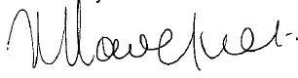
Kate Davenport QC
Chairperson

Membership and attendance

Membership

Lay members
Ms Kate Davenport QC (Chairperson)
Membership category: expertise in the law
Date of first appointment: 7 August 2008
Current term expires: 21 July 2014*
Ms Kate Davenport QC is a barrister sole practising in the area of civil and commercial litigation in Auckland. Kate has an LLB Honours, Master of Jurisprudence with Distinction and a post-graduate certificate in Health Science (Ethics). Kate has a particular interest in health law. Kate was the Deputy Chair of the New Zealand Health Practitioners Disciplinary Tribunal, a tribunal that disciplines all registered health practitioners in New Zealand. Kate has also been the Director of Proceedings for the Health and Disability Commissioner.
Dr Brian Fergus
Membership category: consumer perspective
Date of first appointment: 1 April 2012
Current term expires: 1 April 2015*
BSc, MSc (1st class Honours) Auckland, PhD, McGill University, Montreal, Canada
Dr Brian Fergus has previous private-sector experience at management level and senior management consulting experience. He was also elected Board member of Auckland District Health Board, where he chaired the Community Health subcommittee and was a member of the Audit Committee. Currently, he is Chair of Northern A Health and Disability Ethics Committee. Dr Fergus has four children and seven grandchildren.
Dr Adriana Gunder QSM JP
Membership category: disability perspective
Date of first appointment: 1 April 2010
Current term expires: 1 April 2016
Dr Adriana Gunder is a disability representative and a member of both the New Zealand Health Practitioners Disciplinary Tribunal and the National Ethics Advisory Committee (NEAC). Dr Gunder completed her doctoral degree in Biological Sciences and a post-doctoral degree in Biophysics at the University of Pavia, Italy. She is the Chairperson of the Local Council of Auckland Central, East and South of the New Zealand Red Cross. She has been an elected member of the Auckland City Council: Eastern Bays Community Board (2006–2010) and a volunteer of Victim Support (1995–2007).
Dr Carolyn Mason
Membership category: expertise in ethics
Date of first appointment: 21 July 2011
Current term expires: 21 July 2014*
Dr Carolyn Mason is currently a lecturer in Ethics at the University of Canterbury
(2001–present). Before this, she was a lecturer at Lincoln University (2000) and a science research technician (1979–1985). Dr Mason completed a Bachelor of Science in Psychology and Philosophy (1992), a Master of Arts in Philosophy (1999) and a Doctor of Philosophy in Philosophy at the University of Canterbury (2013). She was a member and Chair of the Upper South A Regional Ethics Committee (2005–2008), and a member and Deputy Chair of the Canterbury Regional Health and Disability Ethics Committee (2002–2004). She is currently a member of the University of Canterbury Human Ethics Committee.
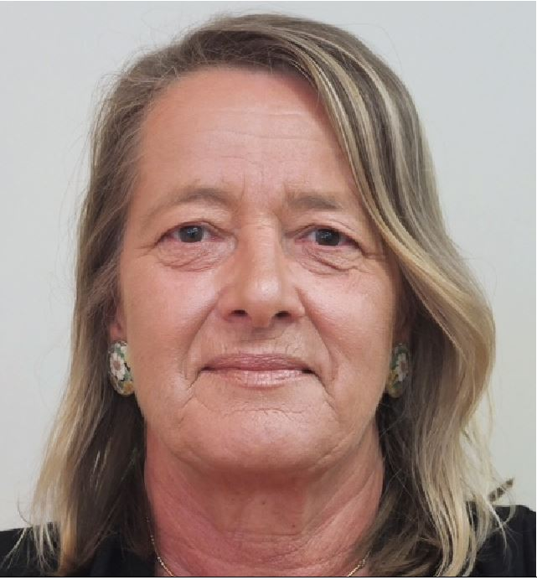 | Ms Jo Fitzpatrick  Membership category: consumer perspective  Date of first appointment: 30 May 2013  Current term expires: 1 April 2015*  Ms Jo Fitzpatrick’s involvement in women’s health provides the foundation for her interest in fertility issues from a consumer perspective. Ms Fitzpatrick has been the Director at Women’s Health Action Trust, a generalist organisation that has represented the broader constituencies in the fertility debate.  The principles that informed the Women’s Health Action Trust submissions in the fertility debate during Ms Fitzpatrick’s time there also form the basis of ECART’s guiding principles. Ms Fitzpatrick’s role at Women’s Health Action Trust has also afforded her extensive opportunities to represent consumers and articulate issues from a consumer perspective.

Non-lay members
Dr Freddie Graham
Membership category: expertise in human reproductive research
Date of first appointment: 21 July 2011
Current term expires: 21 July 2014*
Dr Freddie Graham is currently an obstetrician and gynaecologist at Fertility Associates. He established Fertility Associates as New Zealand’s first private fertility clinic in 1987 and was awarded the Companion of the New Zealand Order of Merit for his services to medicine in 2009. Dr Graham has completed a Bachelor of Medicine and Bachelor of Surgery at the University of London and has been made a Fellow of The Royal College of Surgeons of Edinburgh, as well as a Fellow of The Royal Australian and New Zealand College of Obstetricians and Gynaecologists.
Dr Deborah Payne
Membership category: expertise in assisted reproductive procedures
Date of first appointment: 1 April 2012
Current term expires: 1 April 2014*
Dr Deborah Payne is a senior lecturer and co-director of the Centre for Midwifery and Women’s Health Research at Auckland University of Technology (AUT). She completed her PhD at Massey University in 2003. Dr Payne has a longstanding interest in women’s health. Recent research projects have explored issues in relation to women and disability (eg, motherhood and disability) and assisted reproductive technologies (eg, perceptions of short-cycle IVF, nurses caring for clients undergoing ART and embryo donation). Dr Payne is a member of the Auckland Women’s Health Council.
Dr Deborah Rowe
Membership category: expertise in assisted reproductive procedures
Date of first appointment: 28 June 2007
Current term expires: 21 July 2014*
Dr Deborah Rowe (Ngāi Tahu) is currently a nurse consultant for the Auckland District Health Board (Auckland DHB), a lecturer at The University of Auckland and a senior staff nurse at the Women’s Health Neonatal Intensive Care Unit (NICU). She is a member of the Nursing Council of New Zealand, the Māori Advisory Committee National Screening Unit, the Newborn Screening Advisory Committee, the Auckland DHB Māori Nurses Group, as well as a part-time community support worker for the Intellectually Handicapped of New Zealand (IHC).
* Unless a person vacates their office sooner, every appointed member of ECART shall continue in office until their successor comes into office (ECART Terms of Reference).

Attendance
ECART held five meetings in the year 1 July 2014 to 30 June 2015.

 |  | Meeting dates
 |  | 2/7/14 | 18/9/14 | 14/11/14 | 5/3/15 | 7/5/15 | Total
Members | Ms Kate Davenport (Chair, L) |  |  |  | A |  | 4/5
 | Dr Brian Fergus (C) |  |  |  |  |  | 5/5
 | Dr Adriana Gunder (D) |  |  |  |  |  | 5/5
 | Dr Carolyn Mason (E) |  |  |  |  |  | 5/5
 | Ms Jo Fitzpatrick (C) |  |  |  |  |  | 5/5
 | Dr Freddie Graham (HRR) | A |  |  |  |  | 4/5
 | Dr Deborah Payne (ARP) | A | A |  |  |  | 3/5
 | Dr Deborah Rowe (Deputy Chair, ARP) |  |  | A |  | A | 3/5
 | Total members attending | 6/8 | 7/8 | 7/8 | 7/8 | 7/8 | –
Applications | Surrogacy | 4 | 2 | 7 | 8 | 1 | 22
 | Embryo donation for reproductive purposes | 2 | 5 | 2 | 1 | 3 | 13
 | Donation of eggs or sperm between certain family members | 1 | 3 | 3 | 2 | 0 | 9
 | Creation and use, for reproductive purposes, of an embryo created from donated eggs in conjunction with donated sperm | 1 | 1 | 2 | 0 | 1 | 5
 | Human reproductive research | 0 | 0 | 0 | 0 | 0 | 0
 | Pre-implantation genetic diagnosis | 0 | 0 | 0 | 0 | 1 | 1
 | Total applications reviewed | 8 | 11 | 14 | 11 | 6 | 50
A = Apologies, = Present, = Māori member
Membership categories:
L = expertise in the law
E = expertise in ethics
D = disability perspectives
C = member with the ability to articulate issues from a consumer or community perspective
ARP = member with expertise in assisted reproductive procedures
HRR = member with expertise in human reproductive research

Applications reviewed
ECART reviewed 50 applications in 2014/15. These included five applications for donated eggs in conjunction with donated sperm, zero applications for human reproductive research, nine applications for donation of eggs or sperm between certain family members, 13 applications for embryo donation, 22 applications for surrogacy arrangements involving providers of fertility services and one pre-implantation genetic diagnosis (PGD) with human leucocyte antigen (HLA) tissue typing. (This is the second year in which ECART has reviewed this type of application.)

Figure 1: The number and type of applications reviewed by ECART by year, 2005/06–2014/15
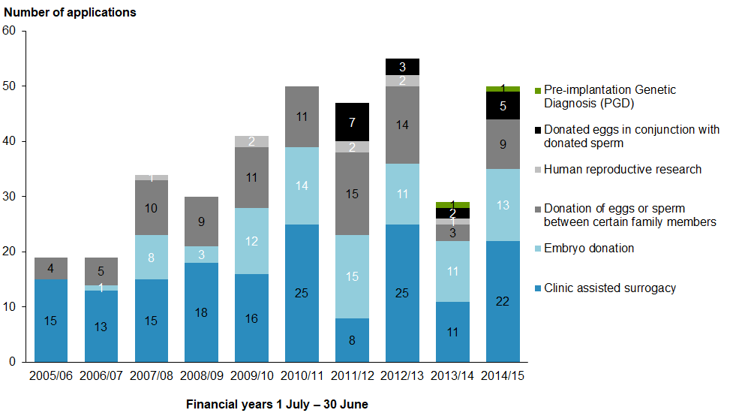

Of the 49 assisted reproductive procedure applications reviewed in 2014/15, 28 were approved at first review, 13 were approved subject to conditions, one was approved with recommendations and seven were deferred.

In this reporting year, ECART reviewed and approved one application for PGD with HLA tissue typing. ECART reviewed this application in accordance with the updated ACART guidelines that came into effect on 18 August 2014. The amended guidelines replaced guidelines issued in 2005 and expanded on PGD with HLA tissue typing to allow its use to find a tissue match for a sick child with a non-genetic disease. PDG with HLA tissue typing may only be used where the child to be treated will be a brother or sister of the resulting child.

This year ECART reviewed 671 storage extension applications. This was a significant increase from the previous year, when ECART reviewed 49 applications for extended storage of gametes and embryos. Details can be found on page 13 of this report.

Creation and use, for reproductive purposes, of an embryo created from donated eggs in conjunction with donated sperm
In 2014/15, ECART reviewed five applications for the creation and use, for reproductive purposes, of an embryo created from donated eggs in conjunction with donated sperm. This is the fourth year in which ECART has reviewed this type of application.

As of 1 July 2015, four applications were approved and one was approved with recommendations.

Applications for this category are current for three years from the date of approval. Of the 18 currently approved applications of this type, there were two live births in 2014/15.

The total number of applications reviewed by ECART to date have resulted in seven births.

Figure 2: Birth outcomes from current applications for the creation and use, for reproductive purposes, of an embryo created from donated eggs in conjunction with donated sperm by year, 2005/06–2014/15
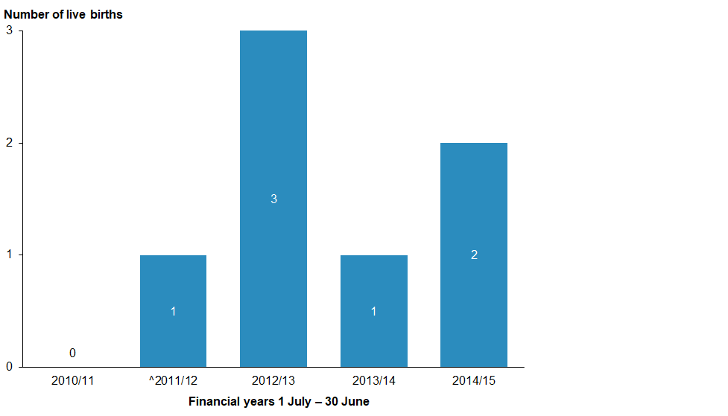
^ 2011/12 was the first year that ECART reviewed this type of application.
* Applications are current for three years; births resulting in the fourth year have not been captured in this figure.

Surrogacy arrangements involving providers of fertility services
In 2014/15, ECART reviewed 22 applications for surrogacy arrangements involving providers of fertility services.

As of 1 July 2015, 19 of the 22 surrogacy applications received by ECART in 2014/15 were approved, and three applications were approved subject to conditions.

The number of clinic-assisted surrogacy applications received in 2014/15 increased by 83 percent from the last reporting year.

Applications for this category are current for three years from the date of approval. From the 67 currently approved surrogacy applications, there were eight live births during 2014/15.

The total number of surrogacy applications approved by ECART have so far resulted in 54 live births.

Figure 3: Birth outcomes from current applications for surrogacy arrangements involving providers of fertility services by year, 2005/06–2014/15
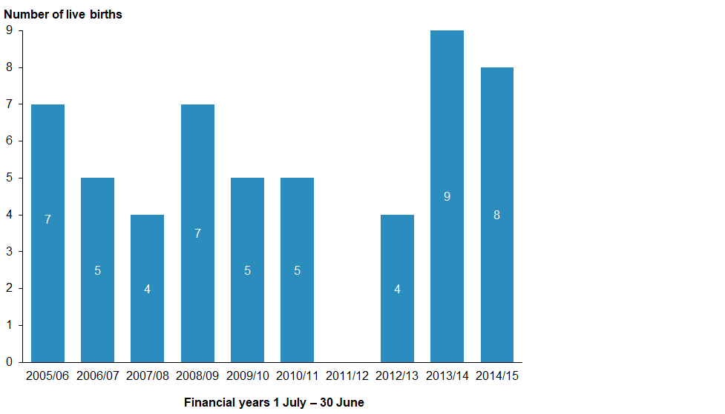
* Applications are current for three years; births resulting in the fourth year have not been captured in this figure.

Donation of eggs or sperm between certain family members
In 2014/15, ECART reviewed nine applications for the donation of eggs or sperm between family members, which is an increase of 200 percent from the previous year.

As of 1 July 2015, seven applications had been approved, and two were approved subject to conditions.

Applications for this category are current for three years from the date of approval. Of the 38 currently approved applications of this type, there were six live births during 2014/15.

Figure 4: Birth outcomes from current applications for the donation of eggs or sperm between certain family members by year, 2005/06–2014/15
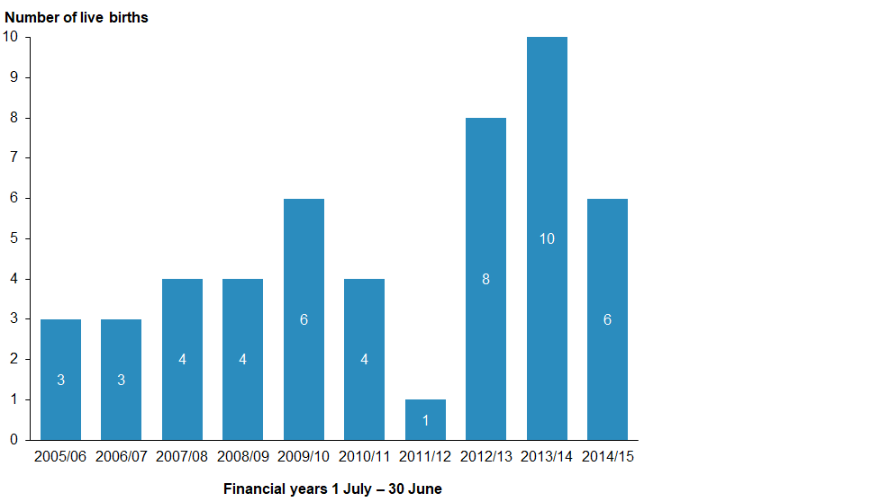
* Applications are current for three years; births resulting in the fourth year have not been captured in this figure.

Embryo donation for reproductive purposes
ECART reviewed 13 applications involving embryo donation for reproductive purposes in 2014/15. This is two more than the previous year.

As of 1 July 2015, there were 12 approved applications and one deferred.

Applications for this category are current for three years from the date of approval. Of the 46 currently approved applications for embryo donation, there were five live births during 2014/15.

The total number of embryo donation applications approved by ECART have so far resulted in 32 live births.

Figure 5: Birth outcomes for current applications from embryo donation, by year, 2005/06–2014/15
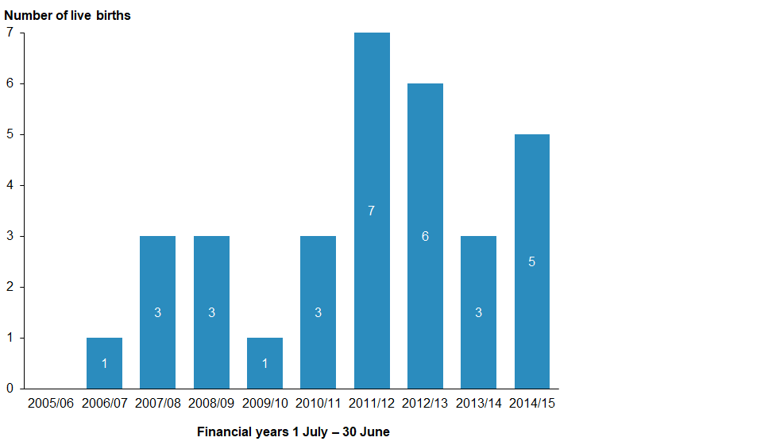
* Applications are current for three years; births resulting in the fourth year have not been captured in this figure.

Storage extension applications
This year, ECART reviewed 671 storage extension applications. This was an extensive increase from the previous year of just 49 applications.

At the first review, 239 applications were approved, and six were declined. A further 426 patients were unable to be located as their stored material approached the expiry of the 10-year storage period. ECART granted a one-year extension to allow clinics to make further attempts to contact these patients. This approval carried the limitation that neither the clinic nor the patients could use the stored gametes or embryos until the patient had submitted a storage extension application and received ECART approval.

Figure 6: The number of storage extension applications received for 2013/14 and 2014/15
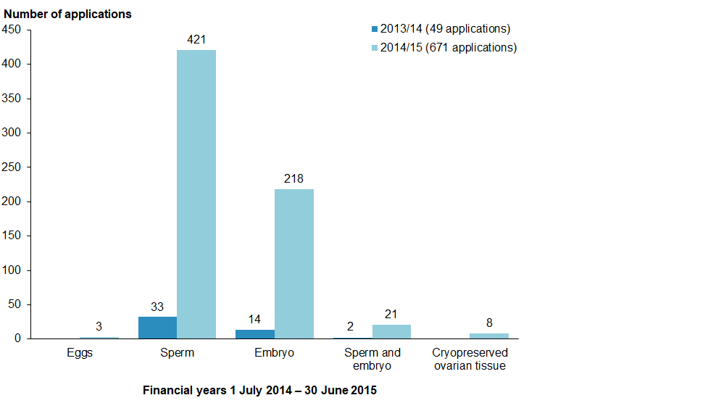

Of the six declined applications:
- two applications to extend the storage of embryos were declined as ECART can only approve an extension in relation to embryos where both parties have given their consent (in both cases, one of the parties did not consent to extending storage)
- another two applications to extend the storage of embryos to allow for the potential future use of stem cells were declined as the taking of stem cells from viable embryos is not permitted under New Zealand law and ECART cannot approve an application on that basis
- one application to extend the storage period of embryos created with donor eggs was declined primarily because ECART was concerned that the reason advanced for the storage, if it eventuated, would result in intergenerational effects, for example, the applicant’s son’s partner would in effect be carrying the applicant’s son’s half sibling, born a generation apart (no information was provided to suggest that the applicant’s sons have a medical condition likely to render them infertile. ECART advised that if the primary aim was for the applicant’s sons to have a backstop in case they develop fertility issues in the future, they could store their own sperm)
- one application to extend donor sperm was declined as, due to the age of the donor, it would not be in the best interests of the potential child as that child might not have access to the donor, which would mean a potential loss of access to family history.

Issues and complaints
This section outlines issues faced by the committee during 2014/15.

Advice on established procedures
In February 2011, the Minister of Health assigned ECART the function of giving ethical advice to fertility clinics on established procedures when requested by a fertility clinic to do so.

ECART gave non-binding ethical advice on one surrogacy arrangement that involved an established procedure as the birth mother’s own eggs were used. ECART advised the fertility provider that it was supportive of the fertility provider’s decision to seek non-binding ethical advice on the proposed surrogacy given that surrogacy is ethically and legally complex and involves risks for the adult parties and resulting children. ECART advised the fertility provider that the proposed surrogacy was justified in light of the associated risks.

Issues referred to ACART
No issues were referred to ACART in 2014/15.

Complaints received
ECART did not receive any complaints during 2014/15.

Appendix A: Applications reviewed by ECART in 2014/15
App# | Date of first review | Initial decision | Date of final review | Final decision | Type of procedure | Approval end date | Is treatment finished?
E11/22 | 02/07/2014 | Approved |  |  | Extension: embryo donation | 03/07/2017 | No
E11/31 | 02/07/2014 | Approved |  |  | Extension: embryo donation | 03/07/2017 | Yes
E11/32 | 02/07/2014 | Approved |  |  | Extension: embryo donation | 03/10/2017 | No
E12/28 | 14/11/2014 | Approved |  |  | Clinic-assisted surrogacy | 01/12/2017 | No
E14/113 | 02/07/2014 | Approved STC |  |  | Clinic-assisted surrogacy | 25/08/2017 | Yes
E14/114 | 02/07/2014 | Approved STC |  |  | Clinic-assisted surrogacy | 29/10/2017 | Yes
E14/115 | 02/07/2014 | Approved STC |  |  | Donation of eggs or sperm between certain family members | 25/07/2017 | Yes
E14/116 | 02/07/2014 | Approved STC |  | Approved | Clinic-assisted surrogacy | 29/10/2017 | No
E14/117 | 02/07/2014 | Approved STC |  | Approved | Clinic-assisted surrogacy | 30/07/2017 | Yes
E14/118 | 02/07/2014 | Approved |  |  | Embryo created from donated eggs in conjunction with donated sperm | 03/07/2017 | Yes
E14/147 | 18/09/2014 | Deferred |  | Approved | Embryo donation | 9/12/2017 | Yes
E14/148 | 18/09/2014 | Approved |  |  | Donation of eggs or sperm between certain family members | 03/10/2017 | Yes
E14/149 | 18/09/2014 | Approved |  |  | Donation of eggs or sperm between certain family members | 03/10/2017 | No
E14/150 | 18/09/2014 |  |  |  | Traditional surrogacy – non-binding ethical advice given
E14/151 | 18/09/2014 | Approved |  |  | Clinic-assisted surrogacy | 03/10/2017 | No
E14/153 | 18/09/2014 | Approved |  |  | Embryo created from donated eggs in conjunction with donated sperm | 03/10/2017 | No
E14/154 | 18/09/2014 | Approved STC |  | Approved | Embryo donation | 06/11/2017 | Yes
E14/155 | 18/09/2014 | Deferred |  | Approved | Embryo donation | 20/10/2017 | No
E14/156 | 18/09/2014 | Approved |  |  | Donation of eggs or sperm between certain family members | 03/10/2017 | No
E14/157 | 18/09/2014 | Deferred |  | Approved | Embryo donation | 06/11/2017 | Yes
E14/241 | 14/11/2014 | Approved |  |  | Clinic-assisted surrogacy | 01/12/2017 | No
E14/242 | 14/11/2014 | Approved |  |  | Donation of eggs or sperm between certain family members | 01/12/2017 | No
E14/243 | 14/11/2014 | Approved STC |  |  | Donation of eggs or sperm between certain family members | 01/12/2017 | Yes
E14/244 | 14/11/2014 | Approved |  |  | Embryo created from donated eggs in conjunction with donated sperm | 01/12/2017 | No
E14/245 | 14/11/2014 | Approved STC |  | Approved | Clinic-assisted surrogacy | 10/12/ 2017 | Yes
E14/246 | 14/11/2014 | Approved STC |  | Approved | Clinic-assisted surrogacy | 19/12/ 2017 | Yes
E14/247 | 14/11/2014 | Approved STC |  | Approved | Clinic-assisted surrogacy | 10/02/ 2018 | No
E14/249 | 14/11/2014 | Approved STC |  | Approved | Clinic-assisted surrogacy | 21/01/ 2018 | No
E14/250 | 14/11/2014 | Approved |  |  | Embryo donation | 01/12/ 2017 | Yes
E14/251 | 14/11/2014 | App with recs |  |  | Embryo created from donated eggs in conjunction with donated sperm | 01/12/ 2017 | Yes
E14/252 | 14/11/2014 | Deferred |  | Approved | Embryo donation | 31/03/2018 | No
E14/253 | 14/11/2014 | Approved |  |  | Donation of eggs or sperm between certain family members | 01/12/ 2017 | No
E14/254 | 14/11/2014 | Approved |  |  | Clinic-assisted surrogacy | 01/12/ 2017 | Yes
E15/02 | 05/03/2015 | Approved |  |  | Clinic-assisted surrogacy | 17/03/2018 | No
E15/03 | 05/03/2015 | Approved |  |  | Clinic-assisted surrogacy | 17/03/2018 | Yes
E15/04 | 05/03/2015 | Approved |  |  | Clinic-assisted surrogacy | 17/03/2018 | No
E15/05 | 05/03/2015 | Approved |  |  | Clinic-assisted surrogacy | 17/03/2018 | No
E15/06 | 05/03/2015 | Approved |  |  | Embryo created from donated eggs in conjunction with donated sperm | 17/03/2018 | No
E15/07 | 05/03/2015 | Approved STC |  | Approved | Embryo donation | 29/06/ 2018 | No
E15/08 | 05/03/2015 | Deferred |  | Approved | Clinic-assisted surrogacy | 25/05/ 2018 | No
E15/09 | 05/03/2015 | Approved |  |  | Clinic-assisted surrogacy | 17/03/2018 | No
E15/10 | 05/03/2015 | Approved |  |  | Clinic-assisted surrogacy | 17/03/2018 | No
E15/11 | 05/03/2015 | Approved |  |  | Clinic-assisted surrogacy | 17/03/2018 | No
E15/12 | 05/03/2015 | Approved |  |  | Embryo created from donated eggs in conjunction with donated sperm | 17/03/2018 | No
E15/38 | 07/05/2015 | Deferred |  | Approved | Embryo donation | 08/06/ 2018 | No
E15/39 | 07/05/2015 | Approved |  |  | Embryo created from donated eggs in conjunction with donated sperm | 25/05/2018 | No
E15/40 | 07/05/2015 | Deferred |  | Declined | Embryo donation
E15/41 | 07/05/2015 | Approved |  |  | Embryo donation | 25/05/2018 | No
E15/42 | 07/05/2015 | Approved STC |  | Approved | Clinic-assisted surrogacy | 25/05/2018 | No
E15/43 | 07/05/2015 | Approved |  |  | Pre-implantation genetic diagnosis | 25/05/2018 | No

Appendix B: Applications reviewed by ECART before 1 July 2014 but ongoing throughout 2014/15
App# | Date of first review | Initial decision | Date of final review | Final decision | Procedure | Approval end date | Is the procedure finished?
E09/27 | 07/03/ 2013 | Approved STC |  | Approved | Extension to Donation of eggs or sperm between certain family members | 11/04/2016 | No
E10/42 | 25/11/2010 | Approved |  |  | Clinic-assisted Surrogacy | 05/03/2015 | Yes
E10/42 | 05/05/2014 | Deferred |  | Approved | Clinic-assisted Surrogacy | 27/05/2017 | No
E11/03 | 17/02/2011 | Deferred |  | Approved | Embryo Donation | 01/12/2014 | Yes
E11/23 | 21/07/2011 | Approved |  |  | Donation of eggs or sperm between certain family members | 04/08/2014 | Yes
E11/24 | 21/07/2011 | App with recs |  | App with recs | Embryo Donation | 04/08/2014 | Yes
E11/25 | 21/07/2011 | Approved STC |  | Approved | Embryo created from donated eggs in conjunction with donated sperm | 11/10/2014 | Yes
E11/26 | 21/07/2011 | Deferred |  | Approved | Embryo Donation | 11/10/2014 | Yes
E11/27 | 21/07/2011 | Approved STC |  | Approved | Donation of eggs or sperm between certain family members | 14/10/2014 | Yes
E11/28 | 21/07/2011 | Approved |  |  | Donation of eggs or sperm between certain family members | 04/08/2014 | Yes
E11/29 | 21/07/2011 | Approved |  |  | Clinic-assisted Surrogacy | 04/08/2014 | Yes
E11/30 | 21/07/2011 | Approved |  |  | Embryo Donation | 04/08/2014 | Yes
E11/31 | 21/07/2011 | Approved |  |  | Embryo Donation | 04/08/2014 | Yes
E11/32 | 29/09/2011 | Approved |  |  | Embryo Donation | 11/10/2014 | No
E11/33 | 29/09/2011 | Approved STC |  | Approved | Embryo Donation | 14/10/2014 | Yes
E11/34 | 29/09/2011 | Approved |  |  | Embryo Donation | 14/10/2014 | Yes
E11/35 | 29/09/2011 | App with recs |  | App with recs | Clinic-assisted Surrogacy | 14/10/2014 | Yes
E11/36 | 29/09/2011 | Approved |  |  | Embryo created from donated eggs in conjunction with donated sperm | 14/10/2014 | Yes
E11/37 | 29/09/2011 | Approved |  |  | Embryo Donation | 14/10/2014 | Yes
E11/38 | 29/09/2011 | Approved |  |  | Embryo Donation | 14/10/2014 | Yes
E11/39 | 29/09/2011 | Approved |  |  | Embryo created from donated eggs in conjunction with donated sperm | 29/09/2014 | Yes
E11/40 | 29/09/2011 | Approved |  |  | Embryo Donation | 29/09/2014 | No
E11/41 | 29/09/2011 | Deferred |  | Approved | Donation of eggs or sperm between certain family members | 14/10/2014 | Yes
E11/42 | 24/11/2011 | Approved STC |  | Approved | Research | 20/01/2015
E11/43 | 24/11/2011 | Approved |  |  | Donation of eggs or sperm between certain family members | 01/12/2014 | Yes
E11/44 | 24/11/2011 | Approved |  |  | Embryo created from donated eggs in conjunction with donated sperm | 01/12/2014 | Yes
E11/45 | 24/11/2011 | Approved |  |  | Donation of eggs or sperm between certain family members | 01/12/2014 | No
E11/46 | 24/11/2011 | Approved |  |  | Embryo created from donated eggs in conjunction with donated sperm | 01/12/2014 | Yes
E11/47 | 24/11/2011 | Approved |  |  | Donation of eggs or sperm between certain family members | 01/12/2014 | Yes
E11/48 | 24/11/2011 | Approved |  |  | Clinic-assisted Surrogacy | 01/12/2014 | Yes
E11/49 | 24/11/2011 | Approved |  |  | Embryo Donation | 01/12/2014 | Yes
E12/01 | 23/02/2012 | Approved |  |  | Donation of eggs or sperm between certain family members | 05/03/2015 | Yes
E12/02 | 23/02/2012 | Approved |  |  | Embryo Donation | 05/03/2015 | Yes
E12/03 | 23/02/2012 | Approved STC |  | Approved | Donation of eggs or sperm between certain family members | 21/03/2015 | Yes
E12/04 | 23/02/2012 | Approved |  |  | Donation of eggs or sperm between certain family members | 05/03/2015 | Yes
E12/05 | 23/02/2012 | Approved STC |  | Approved | Embryo created from donated eggs in conjunction with donated sperm | 16/04/2015 | Yes
E12/06 | 23/02/2012 | Approved |  |  | Embryo created from donated eggs in conjunction with donated sperm | 05/03/2015 | Yes
E12/07 | 23/02/2012 | Approved |  |  | Embryo Donation | 05/03/2015 | Yes
E12/08 | 23/02/2012 | Approved |  |  | Donation of eggs or sperm between certain family members | 05/03/2015 | Yes
E12/09 | 10/05/2012 | Approved STC |  | Approved | Donation of eggs or sperm between certain family members | 14/10/2014 | Yes
E12/10 | 10/05/2012 | Approved |  |  | Embryo Donation | 15/05/2015 | Yes
E12/11 | 10/05/2012 | Approved |  |  | Donation of eggs or sperm between certain family members | 15/05/2015 | Yes
E12/12 | 10/05/2012 | Approved STC |  | Approved | Embryo Donation | 11/06/2015 | Yes
E12/13 | 10/05/2012 | Approved STC |  | Declined | Donation of eggs or sperm between certain family members
E12/14 | 10/05/2012 | Approved |  |  | Donation of eggs or sperm between certain family members | 15/05/2015 | Yes
E12/15 | 10/05/2012 | Approved |  |  | Clinic-assisted Surrogacy | 15/05/2015 | Yes
E12/16 | 10/05/2012 | Approved |  |  | Clinic-assisted Surrogacy | 15/05/2015 | Yes
E12/17 | 10/05/2012 | Approved STC |  |  | Research | 17/06/2015
E12/18 | 10/05/2012 | Approved |  |  | Clinic-assisted Surrogacy | 15/05/2015 | Yes
E12/19 | 19/07/2012 | Approved STC |  | Approved | Embryo created from donated eggs in conjunction with donated sperm | 28/08/2015 | Yes
E12/20 | 19/07/2012 | Deferred |  | App Withdrawn | Clinic-assisted Surrogacy |  | Yes
E12/21 | 19/07/2012 | Approved |  |  | Donation of eggs or sperm between certain family members | 01/08/2015 | Yes
E12/22 | 19/07/2012 | Approved |  |  | Clinic-assisted Surrogacy | 01/08/2015 | Yes
E12/23 | 19/07/2012 | Approved |  |  | Clinic-assisted Surrogacy |  | Yes
E12/24 | 19/07/2012 | Approved |  |  | Donation of eggs or sperm between certain family members | 01/08/2015 | Yes
E12/25 | 19/07/2012 | Approved |  |  | Embryo Donation | 01/08/2015 | Yes
E12/26 | 19/07/2012 | Approved |  |  | Donation of eggs or sperm between certain family members | 01/08/2015 | No
E12/27 | 19/07/2012 | Approved |  |  | Clinic-assisted Surrogacy | 01/08/2015 | Yes
E09/21 | 19/07/2012 | Approved |  |  | Extension request | 01/08/2015
E12/28 | 27/09/2012 | Approved |  |  | Clinic-assisted Surrogacy | 03/10/ 2015 | No
E12/29 | 27/09/2012 | Approved |  |  | Clinic-assisted Surrogacy | 03/10/ 2015 | Yes
E12/30 | 27/09/2012 | Approved |  |  | Donation of eggs or sperm between certain family members | 03/10/ 2015 | Yes
E12/31 | 27/09/2012 | Approved |  |  | Embryo created from donated eggs in conjunction with donated sperm | 03/10/ 2015 | Yes
E12/32 | 27/09/2012 | Approved |  |  | Embryo Donation | 03/10/ 2015 | Yes
E12/33 | 27/09/2012 | Approved |  |  | Embryo created from donated eggs in conjunction with donated sperm | 27/09/2015 | Yes
E12/34 | 27/09/2012 | Approved |  |  | Clinic-assisted Surrogacy | 27/09/2015 | Yes
E12/35 | 27/09/2012 | Approved |  |  | Embryo Donation | 27/09/2015 | Yes
E12/36 | 27/09/2012 | Approved |  |  | Embryo Donation | 27/09/2015 | Yes
E12/37 | 27/09/2012 | Approved STC |  |  | Donation of eggs or sperm between certain family members | 27/09/2015 | No
E12/38 | 27/09/2012 | Approved |  |  | Clinic-assisted Surrogacy | 27/09/2015 | Yes
E12/39 | 29/11/2012 | Approved |  |  | Embryo Donation | 06/12/2015 | Yes
E12/40 | 29/11/2012 | Approved |  |  | Clinic-assisted Surrogacy | 06/12/2015 | Yes
E12/41 | 29/11/2012 | Approved |  |  | Clinic-assisted Surrogacy | 06/12/2015 | Yes
E12/42 | 29/11/2012 | Approved |  |  | Clinic-assisted Surrogacy | 06/12/2015 | Yes
E12/43 | 29/11/2012 | Approved |  |  | Clinic-assisted Surrogacy | 06/12/2015 | Yes
E12/44 | 29/11/2012 | Approved |  |  | Donation of eggs or sperm between certain family members | 06/12/2015 | Yes
E12/45 | 29/11/2012 | Approved |  |  | Donation of eggs or sperm between certain family members | 06/12/2015 | Yes
E12/46 | 29/11/2012 | Deferred |  | Approved | Donation of eggs or sperm between certain family members | 18/02/2016 | No
E12/47 | 29/11/2012 | Approved |  |  | Embryo donation | 06/12/2015 | Yes
E12/48 | 29/11/2012 | Approved STC |  | Approved | Clinic-assisted surrogacy | 11/01/2016 | Yes
E13/01 | 07/03/2013 | Approved |  |  | Clinic-assisted surrogacy | 08/03/2016 | No
E13/02 | 07/03/2013 | Approved |  |  | Embryo donation | 08/03/2016 | No
E13/03 | 07/03/2013 | Approved STC |  |  | Clinic-assisted surrogacy | 08/03/2016 | Yes
E13/04 | 07/03/2013 | Approved |  |  | Clinic-assisted surrogacy | 08/03/2016 | Yes
E13/05 | 07/03/2013 | Approved |  |  | Clinic-assisted surrogacy | 08/03/2016 | Yes
E13/06 | 07/03/2013 | Approved |  |  | Embryo donation | 08/03/2016 | Yes
E13/07 | 07/03/2013 | Approved |  |  | Clinic-assisted surrogacy | 08/03/2016 | Yes
E13/08 | 07/03/2013 | Approved |  |  | Embryo donation | 08/03/2016 | Yes
E13/09 | 07/03/2013 | Deferred |  | Approved | Clinic-assisted surrogacy | 14/11/2016 | No
E13/10 | 07/03/2013 | Approved STC |  | Approved | Clinic-assisted surrogacy+ embryo donation | 08/05/2016 | Yes
E13/11 | 30/05/2013 | Approved |  |  | Donation of eggs or sperm between certain family members | 04/06/2016 | No
E13/12 | 30/05/2013 | Approved |  |  | Clinic-assisted surrogacy | 04/06/2016 | No
E13/13 | 30/05/2013 | Approved |  |  | Clinic-assisted surrogacy | 04/06/2016 | No
E13/14 | 30/05/2013 | Approved |  |  | Donation of eggs or sperm between certain family members | 04/06/2016 | No
E13/15 | 30/05/2013 | Approved |  |  | Donation of eggs or sperm between certain family members | 04/06/2016 | Yes
E13/16 | 30/05/2013 | Approved STC |  |  | Clinic-assisted surrogacy | 13/07/2016 | Yes
E13/17 | 30/05/2013 | Approved |  |  | Embryo donation | 04/06/2016 | Yes
E13/18 | 30/05/2013 | Approved |  |  | Embryo donation | 04/06/2016 | No
E13/19 | 30/05/2013 | Deferred |  | App withdrawn | Donation of eggs or sperm between certain family members
E13/20 | 30/05/2013 | Approved |  |  | Clinic-assisted surrogacy | 04/06/2016 | No
E13/21 | 30/05/2013 | Approved |  |  | Clinic-assisted surrogacy | 30/05/2016 | Yes
E13/22 | 30/05/2013 | Deferred |  |  | Research
E13/23 | 30/05/2013 | Approved |  |  | Research
E10/09 | 07/03/2013 | Approved STC |  | Approved | Extension request to clinic-assisted surrogacy | 02/04/2016
E13/24 | 01/08/2013 | Approved |  |  | Donation of eggs or sperm between certain family members | 02/08/2016 | Yes
E13/25 | 01/08/2013 | Approved |  |  | Embryo donation | 02/08/2016 | No
E13/26 | 01/08/2013 | Approved STC |  |  | Pre-implantation genetic diagnosis | 02/08/2016
E13/27 | 05/09/2013 | Approved |  |  | Embryo donation | 18/09/2016 | Yes
E13/28 | 05/09/2013 | Approved |  |  | Embryo donation | 07/10/2016 | No
E13/29 | 05/09/2013 | Deferred |  | Approved | Clinic-assisted surrogacy | 01/11/2016 | Yes
E13/30 | 05/09/2013 | Approved STC |  |  | Research
E13/32 | 07/11/2013 | Approved STC |  |  | Clinic-assisted surrogacy | 27/02/2017 | No
E13/33 | 07/11/2013 | Approved |  |  | Embryo created from donated eggs in conjunction with donated sperm | 14/11/2016
E13/34 | 07/11/2013 | Approved |  |  | Embryo donation | 14/11/2016 | Yes
E13/35 | 07/11/2013 | Approved |  |  | Embryo donation | 14/11/2016 | No
E13/36 | 07/11/2013 |  |  |  | Clinic-assisted surrogacy | 14/11/2016 | Yes
E10/47 | 07/11/2013 | Approved |  |  | Donation of eggs or sperm between certain family members | 14/11/2016 | No
E14/01 | 06/03/2014 | Approved |  |  | Clinic-assisted surrogacy | 14/03/2017 | Yes
E14/02 | 06/03/2014 | Deferred |  |  | Embryo donation |  | Yes
E14/03 | 06/03/2014 | Approved STC |  |  | Embryo donation |  | No
E14/04 | 06/03/2014 | Approved |  |  | Clinic-assisted surrogacy | 14/03/2017 | Yes
E14/05 | 06/03/2014 | Approved |  |  | Clinic-assisted surrogacy | 14/03/2017 | No
E14/06 | 06/03/2014 | Deferred |  | Approved | Clinic-assisted surrogacy | 05/05/2017 | Yes
E14/07 | 06/03/2014 | Approved |  |  | Donation of eggs or sperm between certain family members | 14/03/2017 | No
E14/08 | 06/03/2014 | Approved |  |  | Clinic-assisted surrogacy | 14/03/2017 | No
E14/56 | 05/05/2014 | Approved |  |  | Embryo donation | 13/05/2017 | No
E14/57 | 05/05/2014 | Approved |  |  | Embryo donation | 13/05/2017 | Yes
E14/58 | 05/05/2014 | Approved |  |  | Clinic-assisted surrogacy | 13/05/2017 | Yes
E14/59 | 05/05/2014 | Approved STC |  | Approved | Clinic-assisted surrogacy | 17/06/2017 | Yes
E14/62 | 05/05/2014 | Approved STC |  | Approved | Embryo created from donated eggs in conjunction with donated sperm | 26/05/2017 | No

Appendix C: Storage extension applications received 1 July 2014–30 June 2015
Note: The 426 patients with stored gametes and embryos reaching expiry that could not be located are not included in the following list.

App# | Stored product | Date of first review | Initial decision | Expiry date
E14/30 | Donated sperm | 10 July 2014 | Approved | 22 November 2020
E14/33 | Gametes (sperm) | 7 July 2014 | Approved | 22 November 2024
E14/65 | Gametes (sperm) | 7 July 2014 | Approved | 22 November 2024
E14/66 | Donated sperm | 10 July 2014 | Approved | 22 November 2019
E14/67 | Gametes (sperm) | 7 July 2014 | Approved | 22 November 2024
E14/68 | Embryos | 9 September 2014 | Approved | 22 November 2017
E14/69 | Embryos | 9 September 2014 | Approved | 22 November 2016
E14/70 | Gametes (sperm) | 7 July 2014 | Approved | 22 November 2024
E14/71 | Gametes (sperm) | 7 July 2014 | Approved | 22 November 2019
E14/72 | Gametes (sperm) | 7 July 2014 | Approved | 22 November 2024
E14/73 | Embryos | 10 July 2014 | Approved | 22 November 2019
E14/74 | Gametes (sperm) | 7 July 2014 | Approved | 22 November2019
E14/75 | Gametes (sperm) | 7 July 2014 | Approved | 22 November 2024
E14/76 | Gametes (sperm) | 7 July 2014 | Approved | 22 November 2024
E14/77 | Gametes (sperm) | 7 July 2014 | Approved | 22 November 2019
E14/78 | Gametes (sperm) | 7 July 2014 | Approved | 22 November 2019
E14/79 | Embryos | 9 September 2014 | Approved | 31 December 2016
E14/80 | Embryos | 10 July 2014 | Approved | 22 November 2019
E14/81 | Gametes (sperm) | 7 July 2014 | Approved | 22 November 2019
E14/82 | Gametes (sperm) | 7 July 2014 | Approved | 22 November 2019
E14/83 | Gametes (sperm) | 10 July 2014 | Approved | 22 November 2019
E14/84 | Gametes (sperm) | 7 July 2014 | Approved | 22 November 2019
E14/85 | Gametes (sperm) | 7 July 2014 | Approved | 22 November 2019
E14/86 | Embryos | 9 September 2014 | Approved | 22 November 2022
E14/87 | Embryos | 9 September 2014 | Approved | 22 November 2019
E14/88 | Embryos | 2 July 2014 | Approved | 22 November 2018
E14/89 | Gametes (sperm) | 7 July 2014 | Approved | 22 November 2029
E14/90 | Gametes (sperm) | 7 July 2014 | Approved | 22 November2029
E14/91 | Embryos | 9 September 2014 | Approved | 22 November 2016
E14/92 | Embryos | 9 September 2014 | Approved | 22 November 2017
E14/93 | Gametes (sperm) | 2 July 2014 | Approved | 22 November 2024
E14/94 | Embryos | 9 September 2014 | Approved | 22 November 2019
E14/95 | Gametes (sperm) | 7 July 2014 | Approved | 22 November 2019
E14/96 | Gametes (sperm) | 7 July 2014 | Approved | 22 November 2019
E14/97 | Gametes (sperm) | 7 July 2014 | Approved | 22 November 2024
E14/98 | Gametes (sperm) | 7 July 2014 | Approved | 22 November 2024
E14/99 | Gametes (sperm) | 7 July 2014 | Approved | 22 November 2024
E14/100 | Gametes (sperm) | 7 July 2014 | Approved | 22 November 2024
E14/101 | Gametes (sperm) | 7 August 2014 | Approved | 22 November 2017
E14/102 | Embryos (sperm) | 2 July 2014 | Approved | 22 November 2018
E14/103 | Gametes (donor sperm) | 10 July 2014 | Approved | 22 November 2019
E14/104 | Embryos with donor sperm | 10 July 2014 | Approved | 22 November 2019
E14/105 | Embryos | 7 August 2014 | Approved | 22 November 2019
E14/106 | Embryos | 7 July 2014 | Approved | 22 November 2024
E14/107 | Gametes (sperm) | 7 July 2014 | Approved | 22 November 2016
E14/108 | Gametes (sperm) | 7 July 2014 | Approved | 22 November 2021
E14/109 | Embryos | 7 August 2014 | Approved | 22 November 2019
E14/110 | Gametes (sperm) | 7 July 2014 | Approved | 22 November2024
E14/111 | Gametes (sperm) | 10 July 2014 | Approved | 22 November 2019
E14/112 | Gametes (sperm) | 7 July 2014 | Approved | 22 November 2019
E14/113 | Gametes (donor sperm) | 10 July 2014 | Approved | 22 November 2019
E14/119 | Gametes (donor sperm) | 7 August 2014 | Approved | 22 November 2019
E14/120 | Embryos | 7 August 2014 | Approved | 22 November 2019
E14/121 | Gametes (donor sperm) | 7 August 2014 | Approved | 22 November 2017
E14/122 | Gametes (sperm) | 7 August 2014 | Approved | 22 November 2016
E14/123 | Gametes (sperm) | 7 August 2014 | Approved | 22 November 2019
E14/124 | Embryos | 7 August 2014 | Approved | 22 November 2019
E14/125 | Gametes (sperm) | 7 August 2014 | Approved | 22 November 2019
E14/126 | Embryos | 7 August 2014 | Approved | 22 November 2019
E14/127 | Gametes (sperm) | 7 August 2014 | Approved | 22 November 2019
E14/128 | Embryos with donor sperm | 7 August 2014 | Approved | 22 November 2019
E14/129 | Embryos | 7 August 2014 | Approved | 22 November 2017
E14/130 | Sperm | 7 August 2014 | Approved | 22 November 2024
E14/131 | Gametes (donor sperm) | 7 August 2014 | Approved | 22 November 2016
E14/132 | Gametes (donor sperm) | 7 August 2014 | Approved | 22 November 2019
E14/133 | Gametes (sperm) | 7 August 2014 | Approved | 22 November 2024
E14/134 | Embryo with donor sperm | 7 August 2014 | Approved | 22 November 2019
E14/135 | Gametes (sperm) | 7 August 2014 | Approved | 22 November 2019
E14/136 | Gametes (donor sperm) | 7 August 2014 | Approved | 22 November 2019
E14/137 | Gametes (ovarian tissue) | 7 August 2014 | Approved | 22 November 2034
E14/138 | Gametes (donor sperm) | 7 August 2014 | Approved | 22 November 2014
E14/139 | Gametes (donor sperm) | 7 August 2014 | Approved | 22 November 2019
E14/140 | Gametes (donor sperm) | 7 August 2014 | Approved | 22 November 2019
E14/141 | Gametes (sperm) | 7 August 2014 | Approved | 22 November 2024
E14/142 | Gametes (sperm) | 7 August 2014 | Approved | 22 November 2024
E14/143 | Embryos with donor sperm | 7 August 2014 | Approved | 20 April 2020
E14/144 | Embryos | 7 August 2014 | Approved | 22 November 2019
E14/145 | Ovarian tissue | 7 August 2014 | Approved | 10 March 2025
E14/146 | Gametes (sperm) | 7 August 2014 | Approved | 22 November 2019
E14/158 | Gametes (sperm) | 18 September 2014 | Approved | 22 November 2015
E14/159 | Embryos | 3 October 2014 | Approved | 22 November 2018
E14/160 | Gametes (sperm) | 3 October 2014 | Approved | 22 November 2019
E14/161 | Gametes (sperm) | 3 October 2014 | Approved | 22 November 2024
E14/162 | Embryos | 3 October 2014 | Approved | 22 November 2019
E14/163 | Embryos with donor sperm | 3 October 2014 | Approved | 22 November 2019
E14/164 | Gametes (donor sperm) | 3 October 2014 | Approved | 22 November 2016
E14/165 | Gametes (sperm) | 3 October 2014 | Approved | 22 November 2024
E14/166 | Gametes (sperm) | 3 October 2014 | Approved | 22 November 2029
E14/167 | Gametes (sperm) | 3 October 2014 | Approved | 22 November 2019
E14/168 | Gametes (sperm) | 3 October 2014 | Approved | 22 November 2024
E14/169 | Embryos | 3 October 2014 | Approved | 22 November 2019
E14/170 | Gametes (sperm) and embryos | 3 October 2014 | Approved | 22 November 2019
E14/171 | Gametes (sperm) | 3 October 2014 | Approved | 22 November 2024
E14/172 | Embryos | 3 October 2014 | Approved | 22 November 2018
E14/173 | Gametes (donor sperm) | 3 October 2014 | Approved | 22 November 2019
E14/174 | Gametes (donor sperm) | 3 October 2014 | Approved | 22 November 2019
E14/175 | Gametes (sperm) | 3 October 2014 | Approved | 22 November 2024
E14/176 | Embryos | 3 October 2014 | Approved | 22 November 2016
E14/177 | Embryos | 3 October 2014 | Approved | 22 November 2019
E14/178 | Embryos (donor sperm and eggs) | 3 October 2014 | Approved | 22 November 2018
E14/179 | Gametes (sperm) | 3 October 2014 | Approved | 22 November 2024
E14/180 | Gametes (sperm) | 3 October 2014 | Approved | 5 February 2029
E14/181 | Embryos with donor sperm | 3 October 2014 | Approved | 22 November 2019
E14/182 | Gametes (sperm) | 3 October 2014 | Approved | 22 November 2024
E14/183 | Embryos | 3 October 2014 | Approved | 22 November 2015
E14/184 | Embryo | 14 November 2014 | Approved | 13 May 2020
E14/185 | Embryos (donor sperm) | 14 November 2014 | Approved | 22 November 2019
E14/186 | Embryos | 14 November 2014 | Approved | Six months 22 May 2015
E14/187 | Embryos | 14 November 2014 | Approved | 22 November 2018
E14/188 | Donor sperm | 14 November 2014 | Approved | 22 November 2017
E14/189 | Gametes (sperm) | 14 November 2014 | Approved | 22 November 2017
E14/190 | Gametes (sperm) | 14 November 2014 | Approved | 13 January 2019 and 24 September 2021
E14/191 | Embryos (donor sperm) | 14 November 2014 | Approved | 22 November 2017
E14/192 | Gametes (sperm) | 14 November 2014 | Approved | 22 November 2019
E14/193 | Gametes (sperm) | 14 November 2014 | Approved | 22 November 2024
E14/194 | Gametes (sperm) | 14 November 2014 | Approved | 22 November 2024
E14/195 | Donor sperm | 14 November 2014 | Approved | 22 November 2017
E14/196 | Embryos | 14 November 2014 | Approved | 22 November 2019
E14/197 | Donor sperm | 14 November 2014 | Approved | 2 July 2020
E14/198 | Embryos with donor sperm | 14 November 2014 | Approved | 22 November 2016
E14/199 | Donor sperm | 14 November 2014 | Approved | 22 November 2024
E14/200 | Embryos | 14 November 2014 | Approved | 22 November 2016
E14/201 | Donor sperm | 14 November 2014 | Approved | 22 November 2016
E14/202a | Embryos with donor egg | 14 November 2014 | Approved | 22 November 2019
E14/202b | Gametes (sperm) | 14 November 2014 | Approved | 22 November 2019
E14/203 | Donor sperm | 14 November 2014 | Approved | 22 November 2019
E14/204 | Donor sperm | 14 November 2014 | Approved | 22 November 2016
E14/205 | Ovarian tissue | 14 November 2014 | Approved | 22 November 2024
E14/206 | Gametes (sperm) | 14 November 2014 | Approved | 22 November 2024
E14/207 | Donor sperm | 14 November 2014 | Approved | 22 November 2019
E14/208 | Gametes (sperm) | 14 November 2014 | Approved | 22 November 2019
E14/209 | Embryos | 14 November 2014 | Approved | 30 October 2019
E14/210 | Gametes (sperm) | 14 November 2014 | Approved | 22 November 2024
E14/211 | Gametes (sperm) | 14 November 2014 | Approved | 28 November 2025
E14/212 | Embryos | 14 November 2014 | Approved | 22 November 2017
E14/213 | Embryos | 14 November 2014 | Approved | 22 November 2017
E14/214 | Donor sperm | 14 November 2014 | Approved | 22 November 2019
E14/215 | Embryos | 14 November 2014 | Approved | 22 November 2015
E14/216 | Sperm | 14 November 2014 | Approved | 22 November 2019
E14/217 | Embryos | 14 November 2014 | Approved | 22 November 2019
E14/218 | Embryos | 14 November 2014 | Approved | 22 November 2019
E14/219 | Embryos | 14 November 2014 | Approved | 22 November 2019
E14/220 | Embryos | 14 November 2014 | Approved | 22 November 2019
E14/221 | Embryos with donor sperm | 14 November 2014 | Approved | 22 November 2016
E14/222 | Embryos | 14 November 2014 | Approved | 22 November 2017
E14/223 | Embryos | 14 November 2014 | Approved | 22 November 2014
E14/224 | Cryopreserved ovarian tissue | 14 November 2014 | Approved | 22 November 2031
E14/225 | Embryos | 14 November 2014 | Approved | 22 November 2016
E14/226 | Cryopreserved ovarian tissue | 14 November 2014 | Approved | 28 June 2030
E14/227 | Donor sperm | 14 November 2014 | Approved | 22 November 2019
E14/228 | Cryopreserved ovarian tissue | 14 November 2014 | Approved | 22 November 2024
E14/229 | Gametes (sperm) | 14 November 2014 | Approved | 22 November 2024
E14/230 | Embryos | 14 November 2014 | Approved | 22 November 2017
E14/231 | Gametes (sperm) | 14 November 2014 | Approved | 22 November 2019
E14/232 | Gametes (sperm) | 14 November 2014 | Approved | 14 June 2029
E14/233 | Embryos | 14 November 2014 | Approved | 22 November 2015
E14/234 | Gametes (sperm) | 14 November 2014 | Approved | 22 November 2019
E14/235 | Gametes (sperm) | 14 November 2014 | Approved | 22 November 2024
E14/236 | Gametes (sperm) | 14 November 2014 | Approved | 22 November 2017
E14/237 | Embryos and donor sperm | 14 November 2014 | Approved | 22 November 2016
E14/238 | Gametes (sperm) | 14 November 2014 | Approved | 25 October 2025
E14/239 | Gametes (sperm) | 14 November 2014 | Approved | 22 November 2024
E14/240 | Embryos | 14 November 2014 | Approved | 22 November 2016
E14/248 | Embryos | 14 November 2014 | Approved | 25 February 2020
E14/255 | Embryos | 14 November 2014 | Approved | 22 November 2019
E14/256 | Embryos | 14 November 2014 | Approved | 16 July 2019
E14/257 | Sperm | 14 November 2014 | Approved | 22 November 2024
E14/258 | Sperm | 14 November 2014 | Approved | 2 February 2025
E14/259 | Eggs | 14 November 2014 | Approved | 22 November 2023
E14/260 | Sperm | 14 November 2014 | Approved | 22 November 2024
E14/261 | Sperm | 14 November 2014 | Approved | 22 November 2016
E14/262 | Embryos | 14 November 2014 | Approved | 21 February 2020
E14/263 | Embryos | 14 November 2014 | Approved | 22 November 2017
E14/264 | Sperm | 14 November 2014 | Approved | 22 November 2024
E14/265 | Sperm | 14 November 2014 | Approved | 22 November 2024
E14/266 | Embryos | 14 November 2014 | Approved | 22 November 2024
E14/267 | Sperm | 14 November 2014 | Approved | 22 November 2017
E14/268 | Sperm | 14 November 2014 | Approved | 22 November 2015
E14/269 | Embryos | 14 November 2014 | Declined
E14/270 | Sperm | 14 November 2014 | Approved | 22 November 2019
E14/271 | Embryos and donor egg | 14 November 2014 | Declined
E14/272 | Sperm | 14 November 2014 | Approved | 22 November 2019
E14/273 | Sperm | 14 November 2014 | Approved | 22 November 2024
E14/274 | Embryos | 14 November 2014 | Approved | 22 November 2016
E14/275 | Donor sperm | 14 November 2014 | Declined
E14/276 | Sperm | 14 November 2014 | Approved | 22 November 2016
E14/277 | Sperm | 14 November 2014 | Approved | 22 November 2021
E14/278 | Embryos | 14 November 2014 | Approved | 22 November 2016
E14/279 | Embryos | 14 November 2014 | Approved | 22 November 2016
E14/280 | Sperm | 14 November 2014 | Approved | 22 November 2024
E14/281 | Embryos | 14 November 2014 | Approved | 22 May 2016
E14/282 | Sperm | 14 November 2014 | Approved | 22 November 2024
E14/283 | Embryos | 14 November 2014 | Approved | 22 November 2016
E14/284 | Sperm | 14 November 2014 | Approved | 22 November 2024
E14/285 | Embryos | 14 November 2014 | Approved | 22 May 2015
E14/286 | Embryos | 14 November 2014 | Approved | 22 November 2015
E14/287 | Embryos | 14 November 2014 | Declined
E14/288 | Embryos and donor egg | 14 November 2014 | Approved | 22 November 2015
E14/289 | Embryos | 14 November 2014 | Declined
E14/290 | Sperm | 14 November 2014 | Approved | 22 November 2015
E14/291 | Sperm | 14 November 2014 | Approved | 22 November 2015
E14/292 | Embryos and sperm | 20 November 2014 | Approved | 22 November 2016
E14/293 | Sperm | 20 November 2014 | Approved | 22 November 2024
E14/294 | Sperm | 20 November 2014 | Approved | 22 November 2019
E14/295 | Embryos | 20 November 2014 | Approved | 22 November 2017
E14/296 | Embryos | 20 November 2014 | Approved | 6 December 2016
E14/297 | Sperm | 20 November 2014 | Approved | 22 November 2034
E14/298 | Embryos | 20 November 2014 | Declined
E14/299 | Sperm | 20 November 2014 | Approved | 22 November 2024
E14/300 | sperm | 20 November 2014 | Approved | 22 November 2019
E14/301 | Sperm | 20 November 2014 | Approved | 14 May 2030
E14/302 | Gametes (sperm) | 20 November 2014 | Approved | 22 November 2030
E14/303 | Sperm | 20 November 2014 | Approved | 22 November 2030
E14/304 | Sperm | 20 November 2014 | Approved | 22 November 2019
E14/305 | Embryos | 20 November 2014 | Approved | 22 November 2015
E14/306 | Embryos | 20 November 2014 | Approved | 22 November 2018
E14/307 | Sperm | 20 November 2014 | Approved | 1 August 2030
E14/308 | Sperm | 20 November 2014 | Approved | 22 November 2024
E15/13 | Embryos | 5 March 2015 | Approved | 7 October 2018
E15/14 | Sperm | 5 March 2015 | Approved | 14 April 2035
E15/15 | Gametes (sperm) | 5 March 2015 | Approved | 24 March 2021 and 15 July 2021
E15/16 | Gametes (sperm) | 5 March 2015 | Approved | 8 August 2025
E15/17 | Gametes (sperm) | 5 March 2015 | Approved | 22 November 2019
E15/18 | Gametes (sperm) | 5 March 2015 | Approved | 21 July 2036 and 18 August 2036
E15/19 | Gametes (sperm) | 5 March 2015 | Approved | 5 November 2035
E15/20 | Embryos | 5 March 2015 | Approved | 30 April 2017
E15/21 | Gametes (sperm) | 5 March 2015 | Approved | 1 August 2025
E15/22 | Embryos | 5 March 2015 | Approved | 15 July 2019 and 23 October 2019
E15/23 | Gametes (sperm) | 5 March 2015 | Approved | 15 March 2036
E15/24 | Embryos | 5 March 2015 | Approved | 22 April 2019
E15/25 | Gametes (sperm) | 5 March 2015 | Approved | 15 July 2025 and 28 January 2026
E15/26 | Donor sperm | 5 March 2015 | Approved | 21 April 2019
E15/27 | Gametes (sperm) | 5 March 2015 | Approved | 22 April 2030 and 23 April 2030
E15/28 | Gametes (sperm) | 5 March 2015 | Approved | 5 October 2035
E15/29 | Embryos | 7 May 2015 | Approved | 20 March 2021 and 21 March 2021
E15/30 | Gametes (sperm) | 7 May 2015 | Approved | 23 January 2040
E15/31 | Gametes (sperm) | 7 May 2015 | Approved | 1 July 2020 and 9 January 2029
E15/32 | Gametes (sperm) | 16 March 2015 | Approved | 13 March 2021
E15/33 | Gametes (sperm) | 19 March 2015 | Approved | 3 April 2031
E15/34 | Donor sperm | 19 March 2015 | Approved | 11 November 2020
E15/35 | Gametes (sperm) | 19 March 2015 | Approved | 7 August 2036
E15/36 | Gametes (sperm) | 13 April 2015 | Approved | 5 January 2026
E15/37 | Gametes (eggs) | 13 April 2015 | Approved | 20 October 2018
E15/49 | Embryos | 28 May 2015 | Approved | 2 June 2017
E15/50 | Embryos | 03 June 2015 | Approved | 6 June 2016

