Annual Report
2011/12

Citation: ECART. 2012. Ethics Committee on Assisted Reproductive Technology Annual Report 2011–2012. Wellington: Ethics Committee on Assisted Reproductive Technology.

Published in October 2012 by the Ethics Committee on Assisted Reproductive Technology,
PO Box 5013, Wellington, New Zealand.

ISBN: 978-0-478-39368-2 (online)
HP: 5531

This document is available on the ECART website: www.ecart.health.govt.nz

Contents

About the Committee 2
Chairperson’s report 3
Membership and attendance 4
Applications reviewed 7
Appendix A - Applications considered by ECART in 2011/12 13
Appendix B - Applications considered by ECART prior to 1 July 2011 but ongoing throughout 2011/12 15

About ECART
ECART is the ethics committee for the purposes of the Human Assisted Reproductive Technology Act 2004 (the HART Act), which aims to secure the benefits of these technologies by promoting and protecting the health, safety, dignity and rights of those involved in them.

Under the HART Act, ECART’s prior approval is required in order to conduct:

- human reproductive research (that is, research that involves the creation or use of human gametes, human embryos or hybrid embryos)

- assisted reproductive procedures, except those that have been declared to be “established procedures”.

ECART reviews applications for human reproductive research and assisted reproductive procedures in accordance with guidelines issued by the Advisory Committee on Assisted Reproductive Technology (ACART).

Purpose of this report
ECART’s Terms of Reference require it to report annually to the Minister of Health.

This report must include information on the membership of the Committee, a summary of the applications reviewed during the year, details of any complaints received (and how they were resolved), and areas of review that caused difficulty in making decisions. The report should also detail the number and type of applications for assisted reproductive procedures and human reproductive research, the date of first review, the final outcome, and the reason for the deferring or declining any applications.

Chairperson’s report
I am pleased to present the seventh Annual Report of the Ethics Committee on Assisted Reproductive Technology (ECART), for the year ending 30 June 2012.

Applications
ECART is the ethics committee for the purposes of the Human Assisted Reproductive Technology Act 2004. ECART’s main role is to review applications from fertility clinics who wish to conduct ‘assisted reproductive procedures’ on individuals, or ‘human reproductive research’, against guidelines issued by the Advisory Committee on Assisted Reproductive Technology (ACART).

In 2011/12, ECART reviewed 47 applications over five meetings; compared with the 2010/11 year when ECART reviewed 50 applications over five meetings. ECART expects the number of applications to grow, in view of the additional category of applications for which ACART has developed guidelines, and recent amendments to the HART Act’s provisions on storage of gamete and embryos. ECART recognises the need for its review process to be as focussed and efficient as possible, and has implemented shorter, simpler application forms to ensure this.

Additional function
Following a request from fertility clinics to be able to approach ECART for informal advice on established procedures, ECART wrote to the Minister of Health asking for this function to be assigned pursuant to section 28(1)(e) of the HART Act. The Minister agreed to assign this function to ECART, and asked for details of such advice to be included in future Annual Reports; these details can be found on page 8 of this report.

Committee members
I wish to record my gratitude and thanks to the committee members who retired in 2011/12; Mrs Jackie Freeman, Ms Hazel Irvine, Dr Lynley Anderson, and Dr John Hutton. All these members worked hard for ECART and made enormous contributions to its workload.

I am also very grateful to all ECART members for their continuing commitment, without which the committee could not function effectively. I look forward to another interesting and fulfilling year in 2012/13.

Kate Davenport
Chairperson

Membership and attendance

Membership
Four new members (Dr Brian Fergus, Dr Freddie Graham, Ms Carolyn Mason, and Dr Deborah Payne) were appointed to ECART during 2011/12.

Lay members

Ms Kate Davenport (Chairperson)
Membership category: expertise in the law
Date of first appointment: 7 August 2008
Current term expires: 21 July 2014

Ms Kate Davenport is a Barrister Sole engaged in commercial and civil litigation, medico-legal litigation, regulatory work and trust and equity litigation. Ms Davenport is currently deputy chair of the Health Practitioners Disciplinary Tribunal and the Real Estate Agents Disciplinary Tribunal. She is a previous member of the Audit Group Royal College Obstetricians and Gynaecologists (2003-2005) and the Ethics Committees of the Auckland District Law Society (2002-2005). Ms Davenport has a PostGrad Cert in Health Science (ethics).

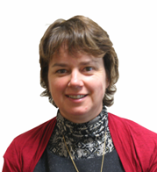 | Dr Lynley Anderson  Membership category: expertise in ethics  Term expired: 7 August 2011  Dr Anderson is a lecturer at the Bioethics Centre at Otago University and teaches ethics and professional development within the medical, physiotherapy, dentistry and midwifery schools at Otago. She was the former and founding editor of the Journal of Bioethical Inquiry and the New Zealand Bioethics Journal. She is on the University of Otago Human Ethics Committee and is the former Chair of the Ethics Committee of the New Zealand Society of Physiotherapists.
Dr Brian Joseph Fergus
Membership category: consumer perspective
Date of first appointment: 1 April 2012
Current term expires: 1 April 2015

B.Sc, M.Sc (1st class Honours) Auckland, Ph.D, McGill University, Montreal, Canada.
Dr Fergus has previous private sector experience at management level and senior management consulting experience. He was also elected Board member of Auckland District Health Board where he chaired the Community Health subcommittee and a member of the Audit Committee. Currently, he is Chair of Northern A Health and Disability Ethics Committee and a member of ECART. Dr Fergus has four children and seven grandchildren.

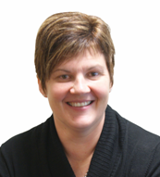 | Mrs Jackie Freeman  Membership category: consumer perspectives  Term expired: 1 April 2012  Ms Jackie Freeman is a part-time primary school teacher with 17 years’ experience. She was a consumer of New Zealand fertility services for 13 years and is married with three daughters through Permanent Foster care and IVF treatment. She is currently a member of Fertility New Zealand and was previously the President for Fertility NZ Canterbury. She has also been a Consumer Auditor for the RTAC Accreditation process.
Dr Adriana Gunder QSM JP
Membership category: disability perspective
Date of first appointment: 1 April 2010
Current term expires: 1 April 2013

Dr Adriana Gunder is a disability representative, a member of the Health Practitioners Disciplinary Tribunal and of the National Ethics Advisory Committee. Dr Gunder completed her Doctoral Degree in Biological Sciences and a Post Doctoral Degree in Biophysics at the University of Pavia, Italy. She is the Chairperson of the Local Council of Auckland Central, East and South of the New Zealand Red Cross. She has been an Elected Member of the Auckland City Council: Eastern Bays Community Board (2006-2010) and a volunteer of Victim Support (1995-2007).

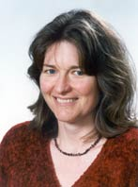 | Ms Carolyn Mason  Membership category: expertise in ethics  Date of first appointment: 21 July 2011  Current term expires: 21 July 2014  Carolyn Mason is currently a Lecturer at the University of Canterbury (2001-present). Prior to this she was a Lecturer at Lincoln University (2000). Ms Mason completed a Bachelor of Science (1992) and a Master of Arts in Philosophy at the University of Canterbury (1999). She was a member and Chair of the Upper South A Regional Ethics Committee (2005-2008), and a member and Deputy Chair of the Canterbury Regional Health and Disability Ethics Committee (2002-2004).
Associate Professor Huia Tomlins-Jahnke
Membership category: expertise in ethics
Date of first appointment: 19 October 2006
Current term expires: 1 April 2013

Associate Professor Huia Tomlins-Jahnke (Ngati Kahungunu, Ngai Tahu, Ngati Toa Rangatira and Ngati Hine) is currently a Māori Education lecturer at Massey University where she has worked for 12 years. She has extensive expertise and experience in Māori theoretical, methodological and ethical frameworks and working with Māori communities. PhD investigated the nature of tribal service provision in health and social services. She is a current member of the Social & Human Sciences Sub Commission of the NZ National Commission for UNESCO and the Sub Commissions Pacific Ethics Consultation Steering Committee.

Non-lay members

Dr Freddie Graham
Membership category: expertise in human reproductive research
Date of first appointment: 21 July 2011
Current term expires: 21 July 2014

Dr Freddie Graham is currently an obstetrician and gynaecologist at Fertility Associates. He established New Zealand’s first private fertility clinic, Fertility Associates (1987) and was awarded the Companion of the New Zealand Order of Merit for his services to medicine in 2009. Dr Graham has completed a Bachelor of Medicine and Bachelor of Surgery at London University, a Fellowship of the Royal College of Surgeons from the Royal College of Surgeons of Edinburgh), as well as a Fellowship of the Royal Australian and New Zealand College of Obstetricians and Gynaecologists.

Professor John Hutton PhD, FRANZCOG, CREI
Membership category: expertise in human reproductive research
Term expired: 7 August 2011

Professor Hutton is a clinician specialising in Reproductive Medicine. Until 2008, he was the Medical Director of Fertility Associates Wellington, where he still works. He is also Professor of Reproductive Endocrinology and Infertility at the Wellington School of Medicine and Health Sciences, and was a Professor of Obstetrics and Gynaecology there between 1983 and 1994. Professor Hutton’s second term expired 7 August 2011.

Ms Hazel Irvine
Membership category: expertise in assisted reproductive procedures
Term expired: 1 April 2012

Ms Hazel Irvine is a registered nurse, midwife, ACC-registered counsellor and psychotherapist. Ms Irvine has worked in the public hospital system as well as private practice – dealing with fertility issues, pregnancy loss, childbirth and postnatal depression. In 2004 Ms Irvine was one of a technical group formed by the Abortion Supervisory Committee to produce Guidelines for Mifepristone Medical Abortion in New Zealand. Ms Irvine is also a member of the Health Practitioners Disciplinary Tribunal.

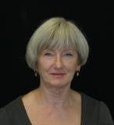 | Dr Deborah Payne  Membership category: expertise in assisted reproductive procedures  Date of first appointment: 1 April 2012  Current term expires: 1 April 2014  Dr Deborah Payne is a senior lecturer and co-director of the Centre for Midwifery & Women’s Health Research at AUT. She completed her PhD at Massey University in 2003. Deborah has a longstanding interest in women’s health. Recent research projects have explored issues in relation to women and disability, e.g. motherhood and disability; assisted reproductive technologies, e.g. perceptions of short cycle IVF, nurses caring for clients undergoing ART, and embryo donation. Deborah is a member of the Auckland Women’s Health Council.
Miss Deborah Rowe
Membership category: expertise in assisted reproductive procedures
Date of first appointment: 28 June 2007
Current term expires: 21 July 2014

Ms Deborah Rowe (Ngāi Tahu) is currently a Nurse Consultant for the Auckland District Health Board, a lecturer at the University of Auckland and a Senior Staff Nurse at the Women’s Health Neonatal Intensive Care Unit. She is a member of the Nursing Council of New Zealand, the Māori Advisory Committee National Screening Unit, the Newborn Screening Advisory Committee, the Auckland District Health Board Māori Nurses Group, the Nursing Council as well as a part time community support worker for the Intellectually Handicapped of New Zealand.

Attendance
ECART held five meetings in 2011/12.
 |  | Meeting dates
 |  | 21/7/11 | 29/9/11 | 24/11/11 | 23/2/12 | 10/5/12 | Total
Members | Ms Kate Davenport (Chair, L) |  |  | A |  |  | 4/5
 | Dr Lynley Anderson (E) | A |  |  |  |  | 0/1
 | Mrs Jackie Freeman (C) |  |  |  |  |  | 4/4
 | Dr Adriana Gunder (D) |  |  |  |  |  | 5/5
 | Assoc Prof Huia Tomlins-Jahnke (E) | A |  |  |  |  | 4/5
 | Ms Carolyn Mason (E) |  |  |  |  |  | 5/5
 | Dr Brian Fergus (C) |  |  |  |  |  | 1/1
 | Dr Freddie Graham (ARP) |  |  |  |  |  | 5/5
 | Professor John Hutton (HRR) | A |  |  |  |  | 0/1
 | Ms Hazel Irvine (ARP) | A |  |  |  |  | 3/4
 | Dr Deborah Payne (C) |  |  |  |  |  | 1/1
 | Miss Deborah Rowe (ARP) |  |  |  | A |  | 4/5
 | Total members attending | 6/10 | 8/8 | 7/8 | 7/8 | 8/8 | -
Applications | Surrogacy | 1 | 1 | 3 | 0 | 3 | 8
 | Embryo Donation for Reproductive Purposes | 4 | 6 | 1 | 2 | 2 | 15
 | Donation of Eggs or Sperm between Certain Family Members | 3 | 1 | 3 | 4 | 4 | 15
 | Creation and use, for reproductive purposes, of an embryo created from donated eggs in conjunction with donated sperm | 1 | 2 | 2 | 2 | 0 | 7
 | Human reproductive research | 0 | 0 | 1 | 0 | 1 | 2
 | Total applications reviewed | 9 | 10 | 10 | 8 | 10 | 47

A = Apologies, = Present, = Māori member

Membership categories: L = expertise in the law
E = expertise in ethics
D = disability perspectives
C = member with the ability to articulate issues for a consumer or community perspective
ARP = member with expertise in assisted reproductive procedures
HRR = member with expertise in human reproductive research

Training and conferences
Dr Francoise Bailey of Dalhousie University spoke to the committee about ethics and assisted human reproduction in Canada on 29 September 2011.

Applications reviewed

ECART reviewed 47 applications in 2011/12. These included seven applications for donated eggs in conjunction with donated sperm (the first year in which ECART has considered this type of applications), two applications for human reproductive research, 15 applications for donation of eggs/sperm between certain family members, 15 applications for embryo donation and eight applications for surrogacy arrangements involving providers of fertility services.

Graph 1 - The number and type of applications reviewed by ECART by year, 2005/06 – 2011/12

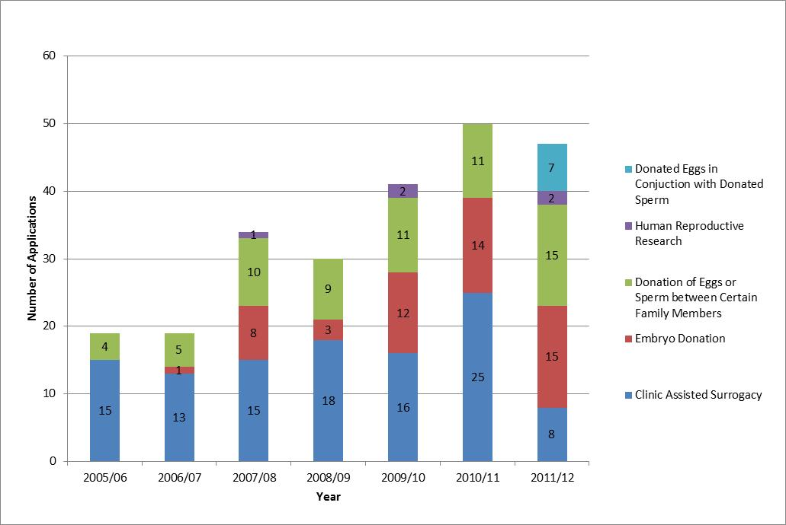

Of the 45 assisted reproductive procedure applications reviewed in 2011/12, 34 were approved at first review, eight approved subject to conditions, two deferred, and one declined. The median times to approval for all the applications received, compared to previous years, are summarised in the table below.

 | 2005/06 | 2006/07 | 2007/08 | 2008/09 | 2009/10 | 2010/11 | 2011/12
Median number of days to approval | 43 | 17 | 17 | 18 | 14 | 14 | 13

Two assisted reproductive procedures approved in 2011/12 resulted in a live birth before 30 June 2011.

ECART received two applications in 2011/12 for human reproductive research.

Creation and use, for reproductive purposes, of an embryo created from donated eggs in conjunction with donated sperm

In 2011/12, ECART reviewed seven applications for the creation and use, for reproductive purposes, of an embryo created from donated eggs in conjunction with donated sperm. This is the first year in which ECART considered this type of application.

As of 1 July 2012, all seven applications were approved.

Applications approved by ECART for the creation and use, for reproductive purposes, of an embryo created from donated eggs in conjunction with donated sperm, have so far resulted in one live birth.

Of the remaining six applications, one did not result in a birth and five are ongoing.

Graph 2 - Outcome of applications for the creation and use, for reproductive purposes, of an embryo created from donated eggs in conjunction with donated sperm by year, 2005/06 – 2011/12

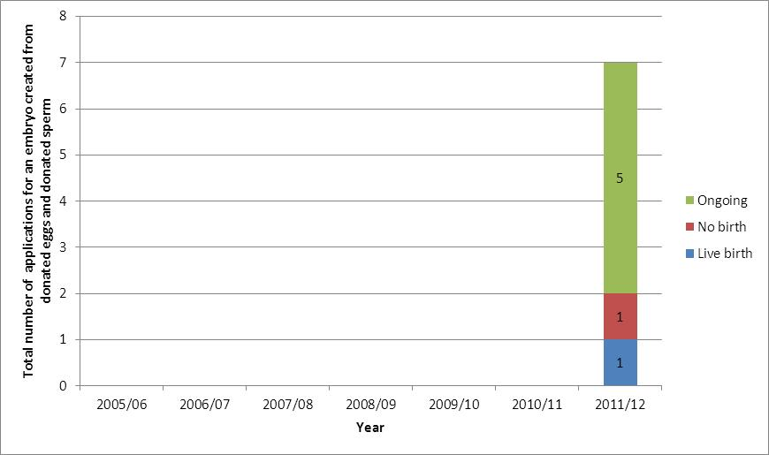
Surrogacy arrangements involving providers of fertility services

In 2011/12, ECART reviewed eight applications for surrogacy arrangements involving providers of fertility services.

As of 1 July 2012, seven of the eight surrogacy applications received by ECART in 2011/12 were approved and one application was declined. The committee agreed to decline this application on the basis of principles b and c of the HART Act 2004.

The number of clinic assisted surrogacy applications received in 2011/12 fell by 68 percent compared to last year, and by about 50 percent compared to reporting years prior to 2010/11.

Surrogacy applications approved by ECART have so far resulted in 33 live births.

Graph 3 - Outcome of applications for surrogacy arrangements involving providers of fertility services by year, 2005/06 – 2011/12

Donation of eggs or sperm between certain family members

In 2011/12, ECART reviewed 15 applications for the donation of eggs or sperm between family members, which is similar to the 11 applications received in 2010/11.

As of 1 July 2012, 13 applications were approved, and two approved subject to conditions.

Twenty-four live births have so far resulted from the use of this assisted reproductive procedure following ECART approval.

Graph 4 - Outcome of applications for the donation of eggs or sperm between certain family members by year, 2005/06 – 2011/12

Embryo donation for reproductive purposes

ECART reviewed 15 applications involving embryo donation for reproductive purposes in 2011/12, one more than in 2010/11.

As of 1 July 2012, 14 applications were approved and one application approved subject to conditions.

Embryo donation applications approved by ECART have so far resulted in 14 live births.

Graph 5 - Outcome of applications for Embryo donation, by year, 2005/06 – 2011/12

Issues and complaints

This section outlines issues faced by the Committee during 2011/12.

Advice on established procedures
In February 2011, the Minister of Health assigned ECART the function of giving ethical advice on established procedures to fertility clinics when requested by them to do so.

No such request was received in 2011/12.

Issues referred to ACART
No issues were referred to ACART in 2011/12

Complaints received
ECART did not receive any complaints during 2011/12.

.

Appendix A - Applications considered by ECART in 2011/12

App # | Date of first review | Final decision | Procedure | Initial Decision | Final Decision | Approval end date | Is treatment finished?
E11/23 | 21 July 2011 | 21 July 2011 | Donation of eggs or Sperm between Certain Family Members | Approved | Approved | 4 August 2014 | Yes
E11/24 | 21 July 2011 | 21 July 2011 | Embryo Donation | Approved | Approved | 4 August 2014 | Yes
E11/25 | 21 July 2011 | 21 July 2011 | Embryo created from donated eggs in conjunction with donated sperm | Approved STC | Approved | 11 October 2014 | No
E11/26 | 21 July 2011 | 21 July 2011 | Embryo Donation | Deferred | Approved | 11 October 2014 | Yes
E11/27 | 21 July 2011 | 29 September 2011 | Donation of eggs or Sperm between Certain Family Members | Approved STC | Approved | 14 October 2014 | No
E11/28 | 21 July 2011 | 21 July 2011 | Donation of eggs or Sperm between Certain Family Members | Approved | Approved | 4 August 2014 | Yes
E11/29 | 21 July 2011 | 21 July 2011 | Clinic-Assisted Surrogacy | Approved | Approved | 4 August 2014 | No
E11/30 | 21 July 2011 | 21 July 2011 | Embryo Donation | Approved | Approved | 4 August 2014 | Yes
E11/31 | 21 July 2011 | 21 July 2011 | Embryo Donation | Approved | Approved | 4 August 2014 | No
E11/32 | 29 September 2011 | 29 September 2011 | Embryo Donation | Approved | Approved | 11 October 2014 | No
E11/33 | 29 September 2011 | 5 October 2011 | Embryo Donation | Approved STC | Approved | 14 October 2014 | No
E11/34 | 29 September 2011 | 29 September 2011 | Embryo Donation | Approved | Approved | 14 October 2014 | No
E11/35 | 29 September 2011 | 29 September 2011 | Clinic-Assisted Surrogacy | Approved | Approved | 14 October 2014 | No
E11/36 | 29 September 2011 | 29 September 2011 | Embryo created from donated eggs in conjunction with donated sperm | Approved | Approved | 14 October 2014 | Yes
E11/37 | 29 September 2011 | 29 September 2011 | Embryo Donation | Approved | Approved | 14 October 2014 | Yes
E11/38 | 29 September 2011 | 29 September 2011 | Embryo Donation | Approved | Approved | 14 October 2014 | Yes
E11/39 | 29 September 2011 | 29 September 2011 | Embryo created from donated eggs in conjunction with donated sperm | Approved | Approved | 29 September 2014 | No
E11/40 | 29 September 2011 | 29 September 2011 | Embryo Donation | Approved | Approved | 29 September 2014 | No
E11/41 | 29 September 2011 | 13 October 2001 | Donation of eggs or Sperm between Certain Family Members | Deferred | Approved | 14 October 2014 | No
E11/42 | 24 November 2011 | 20 January 2012 | Research | Approved STC | Approved | 20 January 2015 | No
E11/43 | 24 November 2011 | 24 November 2011 | Donation of eggs or Sperm between Certain Family Members | Approved | Approved | 1 December 2014 | Yes
E11/44 | 24 November 2011 | 24 November 2011 | Embryo created from donated eggs in conjunction with donated sperm | Approved | Approved | 1 December 2014 | Yes
E11/45 | 24 November 2011 | 24 November 2011 | Donation of eggs or Sperm between Certain Family Members | Approved | Approved | 1 December 2014 | No
E11/46 | 24 November 2011 | 24 November 2011 | Embryo created from donated eggs in conjunction with donated sperm | Approved | Approved | 1 December 2014 | No
E11/47 | 24 November 2011 | 24 November 2011 | Donation of eggs or Sperm between Certain Family Members | Approved | Approved | 1 December 2014 | No
E11/48 | 24 November 2011 | 24 November 2011 | Clinic-Assisted Surrogacy | Approved | Approved | 1 December 2014 | No
E11/49 | 24 November 2011 | 24 November 2011 | Embryo Donation | Approved | Approved | 1 December 2014 | Yes
E10/42 | 25 November 2010 | 5 March 2012 | Clinic-Assisted Surrogacy | Approved | Approved | 5 March 2015 | No
E12/01 | 23 February 2012 | 23 February 2012 | Donation of eggs or Sperm between Certain Family Members | Approved | Approved | 5 March 2015 | No
E12/02 | 23 February 2012 | 23 February 2012 | Embryo Donation | Approved | Approved | 5 March 2015 | No
E12/03 | 23 February 2012 | 21 March 2012 | Donation of eggs or Sperm between Certain Family Members | Approved STC | Approved | 21 March 2015 | No
E12/04 | 23 February 2012 | 23 February 2012 | Donation of eggs or Sperm between Certain Family Members | Approved | Approved | 5 March 2015 | No
E12/05 | 23 February 2012 | 16 April 2012 | Embryo created from donated eggs in conjunction with donated sperm | Approved STC | Approved | 16 April 2015 | No
E12/06 | 23 February 2012 | 23 February 2012 | Embryo created from donated eggs in conjunction with donated sperm | Approved | Approved | 5 March 2015 | No
E12/07 | 23 February 2012 | 23 February 2012 | Embryo Donation | Approved | Approved | 5 March 2015 | Yes
E12/08 | 23 February 2012 | 23 February 2012 | Donation of eggs or Sperm between Certain Family Members | Approved | Approved | 5 March 2015 | No
E12/09 | 10 May 2012 | TBA | Donation of eggs or Sperm between Certain Family Members | Approved STC | TBA | TBA | Yes
E12/10 | 10 May 2012 | 10 May 2012 | Embryo Donation | Approved | Approved | 15 May 2015 | No
E12/11 | 10 May 2012 | 10 May 2012 | Donation of eggs or Sperm between Certain Family Members | Approved | Approved | 15 May 2015 | No
E12/12 | 10 May 2012 | 11 June 2012 | Embryo Donation | Approved STC | Approved | 11 June 2015 | No
E12/13 | 10 May 2012 | TBA | Donation of eggs or Sperm between Certain Family Members | Approved STC | TBA | TBA | No
E12/14 | 10 May 2012 | 10 May 2012 | Donation of eggs or Sperm between Certain Family Members | Approved | Approved | 15 May 2015 | No
E12/15 | 10 May 2012 | 10 May 2012 | Clinic-Assisted Surrogacy | Approved | Approved | 15 May 2015 | No
E12/16 | 10 May 2012 | 10 May 2012 | Clinic-Assisted Surrogacy | Approved | Approved | 15 May 2015 | No
E12/17 | 10 May 2012 | 17 June 2012 | Research | Approved STC | Approved | 17 June 2015 | No
E12/18 | 10 May 2012 | 10 May 2012 | Clinic-Assisted Surrogacy | Approved | Approved | 15 May 2015 | No

Appendix B - Applications considered by ECART prior to 1 July 2011 but ongoing throughout 2011/12

App # | Date of first review | Final decision | Procedure | Initial Decision | Final Decision | Approval end date | Is treatment finished?
2003/13 | 15/05/2008 | 15/05/2008 | Clinic-Assisted Surrogacy | Approved STC | Approved | 15/05/2011 | No
E07/26 | 20/11/2007 | 20/11/2007 | Embryo Donation (re-applying) | Approved | Approved | 6/12/2010 | Yes
E09/10 | 02/04/2009 | 02/04/2009 | Embryo Donation | Approved | Approved | 20/04/2012 | Yes
E09/12 | 11/06/2009 | 11/06/2009 | Donation of eggs or Sperm between Certain Family Members | Approved | Approved | 22/06/2012 | No
E09/18 | 11/08/2009 | 11/08/2009 | Donation of eggs or Sperm between Certain Family Members | Approved | Approved | 27/08/2012 | Yes
E09/21 | 11/08/2009 | 11/08/2009 | Donation of eggs or Sperm between Certain Family Members | Approved | Approved | 27/08/2012 | No
E09/22 | 11/08/2009 | 11/08/2009 | Clinic-Assisted Surrogacy | Approved | Approved | 27/08/2012 | Yes
E09/24 | 11/08/2009 | 11/08/2009 | Embryo Donation | Approved | Approved | 27/08/2012 | Yes
E09/27 | 13/10/2009 | 18/02/2010 | Donation of eggs or Sperm between Certain Family Members | Deferred | Approved | 3/03/2012 | No
E09/34 | 26/11/2009 | 26/11/2009 | Embryo Donation | Approved | Approved | 10/12/2012 | Yes
E09/37 | 26/11/2009 | 18/02/2010 | Clinic-Assisted Surrogacy | Deferred | Approved | 10/12/2012 | Yes
E10/01 | 18/02/2010 | 18/02/2010 | Donation of eggs or Sperm between Certain Family Members | Deferred | Approved | 3/03/2013 | No
E10/08 | 18/02/2010 | 18/02/2010 | Donation of eggs or Sperm between Certain Family Members | Approved | Approved | 3/03/2013 | No
E10/10 | 18/02/2010 | 17/05/2010 | Clinic-Assisted Surrogacy | Deferred | Approved | 17/05/2013 | No
E10/11 | 18/02/2010 | 6/10/2010 | Donation of eggs or Sperm between Certain Family Members | Deferred | Approved | 6/10/2013 | No
E10/13 | 22/04/2010 | 22/04/2010 | Clinic-Assisted Surrogacy | Approved | Approved | 4/05/2013 | No
E10/14 | 22/04/2010 | 21/05/2010 | Embryo Donation | Approved STC | Approved | 21/05/2013 | No
E10/16 | 22/04/2010 | 3/03/2011 | Clinic-Assisted Surrogacy | Approved STC | Approved | 3/03/2014 | Yes
E10/17 | 03/06/2010 | 03/06/2010 | Donation of eggs or Sperm between Certain Family Members | Approved | Approved | 17/06/2013 | No
E10/20 | 03/06/2010 | 03/06/2010 | Clinic-Assisted Surrogacy | Approved | Approved | 17/06/2013 | Yes
E10/23 | 29/07/2010 | 29/07/2010 | Clinic-Assisted Surrogacy | Approved STC | Approved | 28/10/2013 | No
E10/24 | 29/07/2010 | 29/07/2010 | Clinic-Assisted Surrogacy | Approved | Approved | 12/08/2013 | Yes
E10/25 | 29/07/2010 | 8/02/2011 | Donation of eggs or Sperm between Certain Family Members | Deferred | Approved | 8/02/2014 | No
E10/26 | 29/07/2010 | 29/07/2010 | Embryo Donation | Approved | Approved | 12/08/2013 | No
E10/28 | 29/07/2010 | 29/07/2010 | Donation of eggs or Sperm between Certain Family Members | Approved | Approved | 12/08/2013 | Yes
E10/29 | 29/07/2010 | 25/11/2010 | Clinic-Assisted Surrogacy | Deferred | Approved | 9/12/2013 | Yes
E10/31 | 29/07/2010 | 16/09/2010 | Donation of eggs or Sperm between Certain Family Members | Approved STC | Approved | 22/09/2013 | Yes
E10/32 | 29/07/2010 | 17/12/2010 | Clinic-Assisted Surrogacy | Deferred | Deferred | N/A | Yes
E10/33 | 29/07/2010 | 29/07/2010 | Clinic-Assisted Surrogacy | Approved | Approved | 12/08/2013 | Yes
E10/35 | 16/09/2010 | 16/09/2010 | Clinic-Assisted Surrogacy | Approved | Approved | 22/09/2013 | No
E10/38 | 16/09/2010 | 16/09/2010 | Embryo Donation | Approved | Approved | 22/09/2013 | Yes
E10/41 | 25/11/2010 | 25/11/2010 | Donation of eggs or Sperm between Certain Family Members | Approved | Approved | 9/12/2013 | Yes
E10/42 | 25/11/2010 | 15/12/2010 | Clinic-Assisted Surrogacy | Deferred | Approved STC | 15/12/2013 | No
E10/43 | 25/11/2010 | 25/11/2010 | Clinic-Assisted Surrogacy | Approved | Approved | 9/12/2013 | No
E10/44 | 25/11/2010 | 25/11/2010 | Clinic-Assisted Surrogacy | Approved | Approved | 9/12/2013 | No
E10/45 | 25/11/2010 | 25/11/2010 | Clinic-Assisted Surrogacy | Approved | Approved | 9/12/2013 | No
E10/46 | 25/11/2010 | 25/11/2010 | Clinic-Assisted Surrogacy | Approved | Approved | 9/12/2013 | Yes
E10/47 | 25/11/2010 | 25/11/2010 | Donation of eggs or Sperm between Certain Family Members | Approved | Approved | 9/12/2013 | No
E10/49 | 25/11/2010 | 25/11/2010 | Clinic-Assisted Surrogacy | Approved | Approved | 9/12/2013 | Yes
E11/01 | 17/02/2011 | 17/02/2011 | Donation of eggs or Sperm between Certain Family Members | Approved | Approved | 3/03/2014 | No
E11/02 | 17/02/2011 | 17/02/2011 | Clinic-Assisted Surrogacy | Approved | Approved | 3/03/2014 | Yes
E11/03 | 17/02/2011 | 17/02/2011 | Embryo Donation | Deferred | Deferred | N/A | Yes
E11/04 | 17/02/2011 | 17/02/2011 | Donation of eggs or Sperm between Certain Family Members | Approved | Approved | 3/03/2014 | No
E11/05 | 17/02/2011 | 17/02/2011 | Donation of eggs or Sperm between Certain Family Members | Approved | Approved | 3/03/2014 | No
E11/06 | 17/02/2011 | 17/02/2011 | Embryo Donation | Approved | Approved | 3/03/2014 | No
E11/07 | 17/02/2011 | 17/02/2011 | Clinic-Assisted Surrogacy | Approved | Approved | 3/03/2014 | No
E11/08 | 17/02/2011 | 24/03/2011 | Embryo Donation | Approved STC | Approved | 24/03/2014 | Yes
E11/09 | 17/02/2011 | 16/03/2011 | Embryo Donation | Deferred | Approved | 16/03/2014 | Yes
E11/11 | 17/02/2011 | 17/02/2011 | Clinic-Assisted Surrogacy | Approved | Approved | 3/03/2014 | No
E11/12 | 17/02/2011 | 17/02/2011 | Clinic-Assisted Surrogacy | Approved | Approved | 3/03/2014 | Yes
E11/13 | 12/05/2011 | 12/05/2011 | Embryo Donation | Approved | Approved | 26/05/2014 | No
E11/14 | 12/05/2011 | 13/05/2011 | Embryo Donation | Approved STC | Approved | 23/6/2014 | Yes
E11/15 | 12/05/2011 | 12/05/2011 | Clinic-Assisted Surrogacy | Approved | Approved | 26/05/2014 | No
E11/16 | 12/05/2011 | 12/05/2011 | Embryo Donation | Approved | Approved | 26/05/2014 | No
E11/17 | 12/05/2011 | 12/05/2011 | Donation of eggs or Sperm between Certain Family Members | Approved | Approved | 26/05/2014 | No
E11/18 | 12/05/2011 | 12/05/2011 | Donation of eggs or Sperm between Certain Family Members | Approved | Approved | 26/05/2014 | Yes
E11/19 | 12/05/2011 | 12/05/2011 | Embryo Donation | Approved | Approved | 26/05/2014 | Yes
E11/20 | 12/05/2011 | 13/05/2011 | Embryo Donation | Deferred | Approved | 17/06/2014 | Yes
E11/22 | 12/05/2011 | 12/05/2011 | Embryo Donation | Approved | Approved | 26/05/2014 | No

Approved subject to conditions being met
remains deferred for further information about the wellbeing of the birth mother and any resulting child under principles (a) and (c) of the HART Act
remains deferred for further information about the wellbeing of the recipient woman and any resulting child under principles (a) and (c) of the HART Act

